Human Centred Systems Design

Group 9 Project Report

Introduction:

We met every week to discuss our progress on the project. To begin with, we split into pairs and assigned each pair one of either the use case or information model diagram, meeting the following week to review the work and give feedback on each other’s designs. At first, we tried using third party software such as UMLet to create our UML diagrams but in the end decided to do the diagrams within Microsoft based software because it was easier to work with the file types and we were all more familiar with using it. We then, in our pairs, individually did the normalised data model and met up to discuss and compare to produce our final solution. We then made mock ups of the user interfaces and created the database. In the following week, we split the work up and began implementing our design. We decided to use eclipse to build the project in Java as this was something we were all comfortable with using as a result of our first-year java course. In order to collaborate effectively on the working of the Java project we decided to use GitHub as a version control solution, this was easy to use because Git is included within eclipse. When implementing the forms/jframes we used eclipse windows builder as this allowed us to create elegant interfaces that would have otherwise been difficult to hard code. We then met over the following weeks to check up on progress and make sure we were on track. Furthermore, over the duration of the weekly meetings we kept discussing our diagram designs in order to come up with the final designs that we were all happy with. We then had a final group meeting to consolidate all the work and produce the final report.

Use Case Diagram

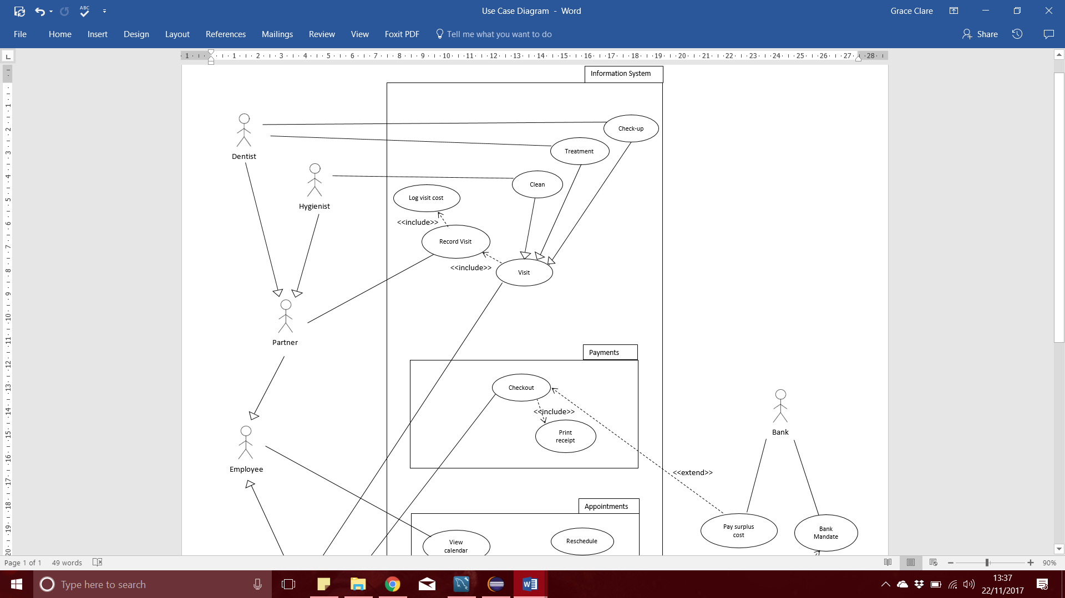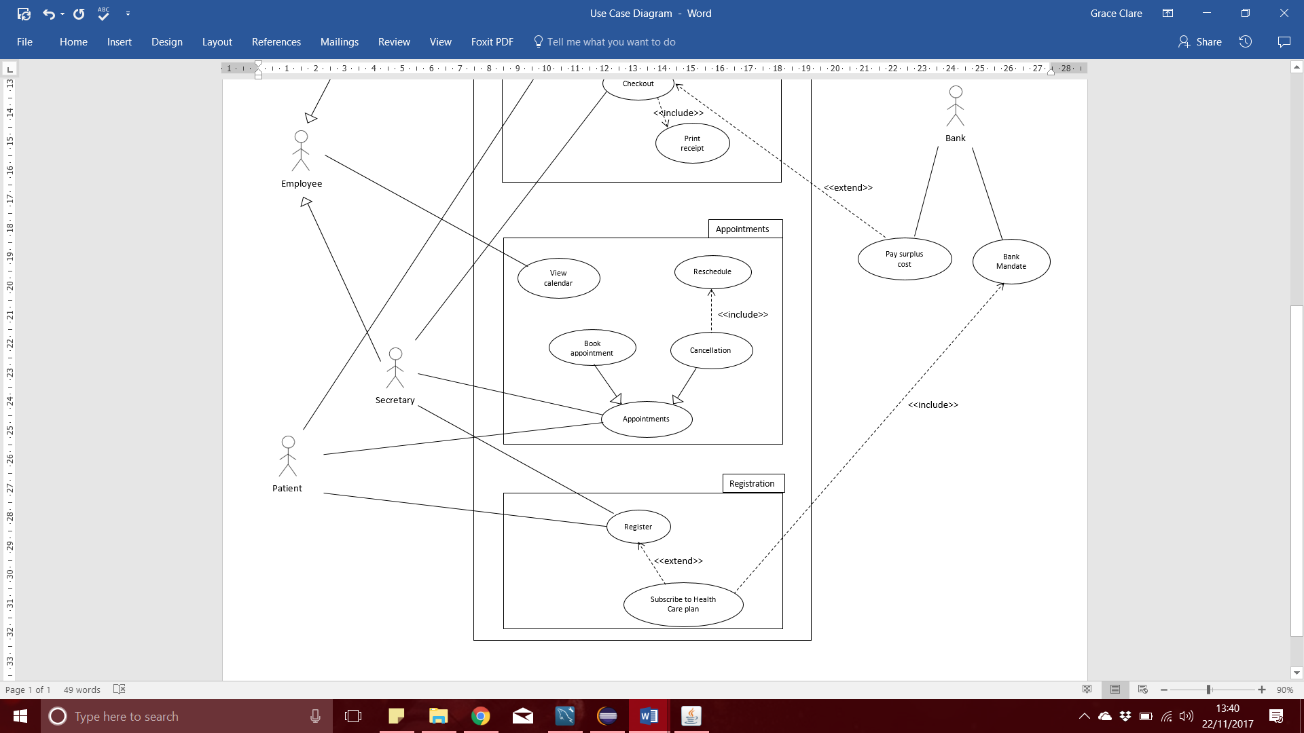

Information Model 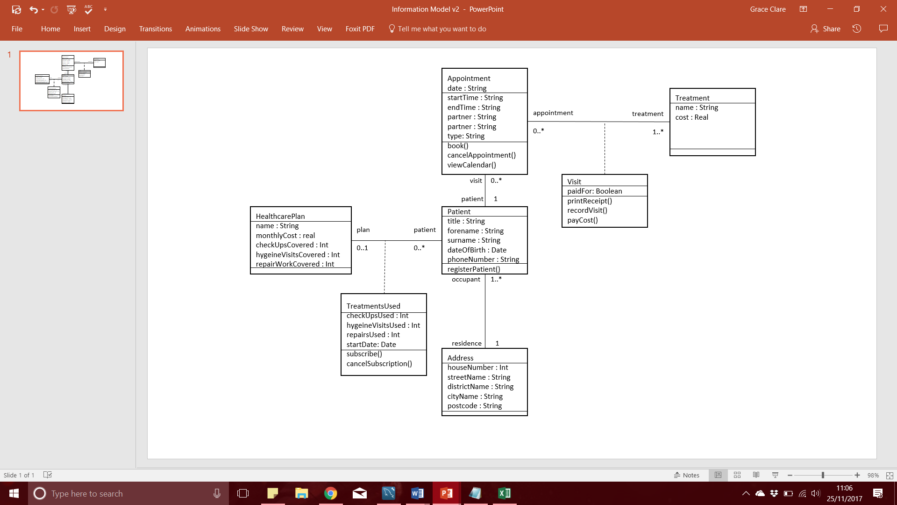

Normalised Data Model 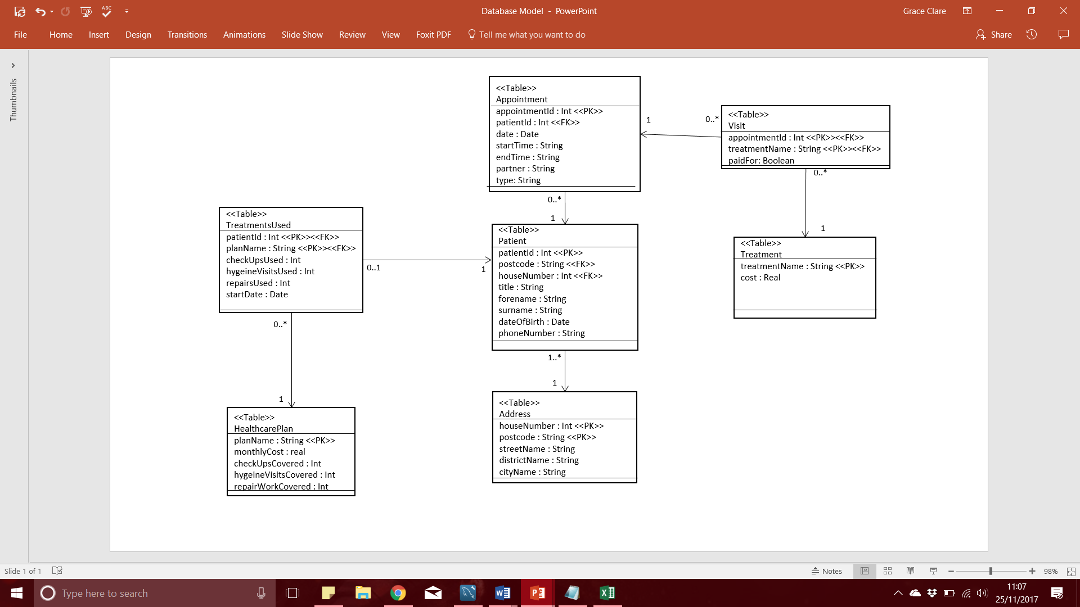

Secretary User Interface

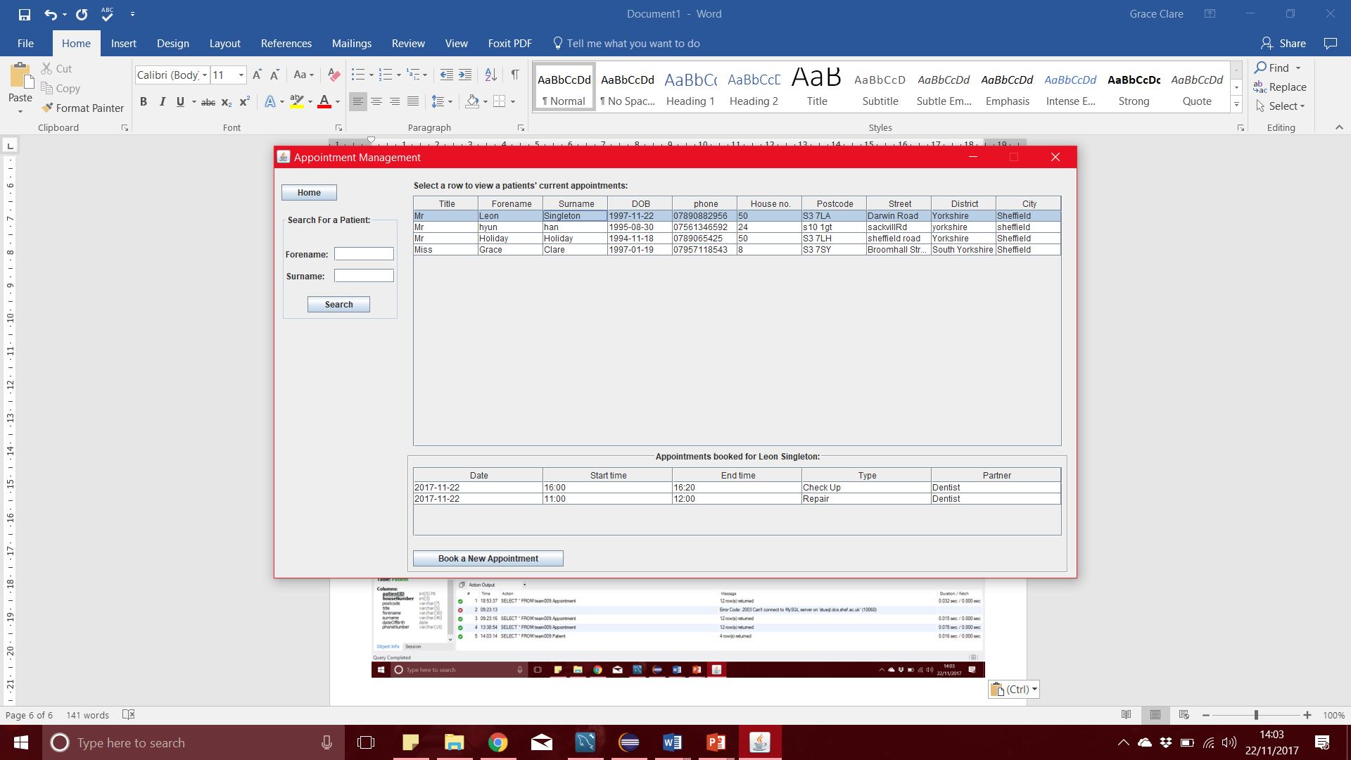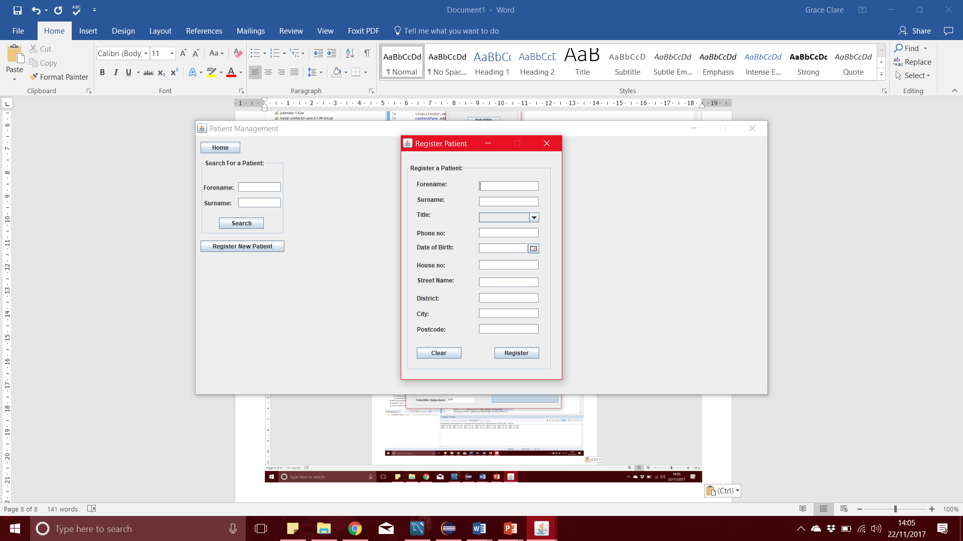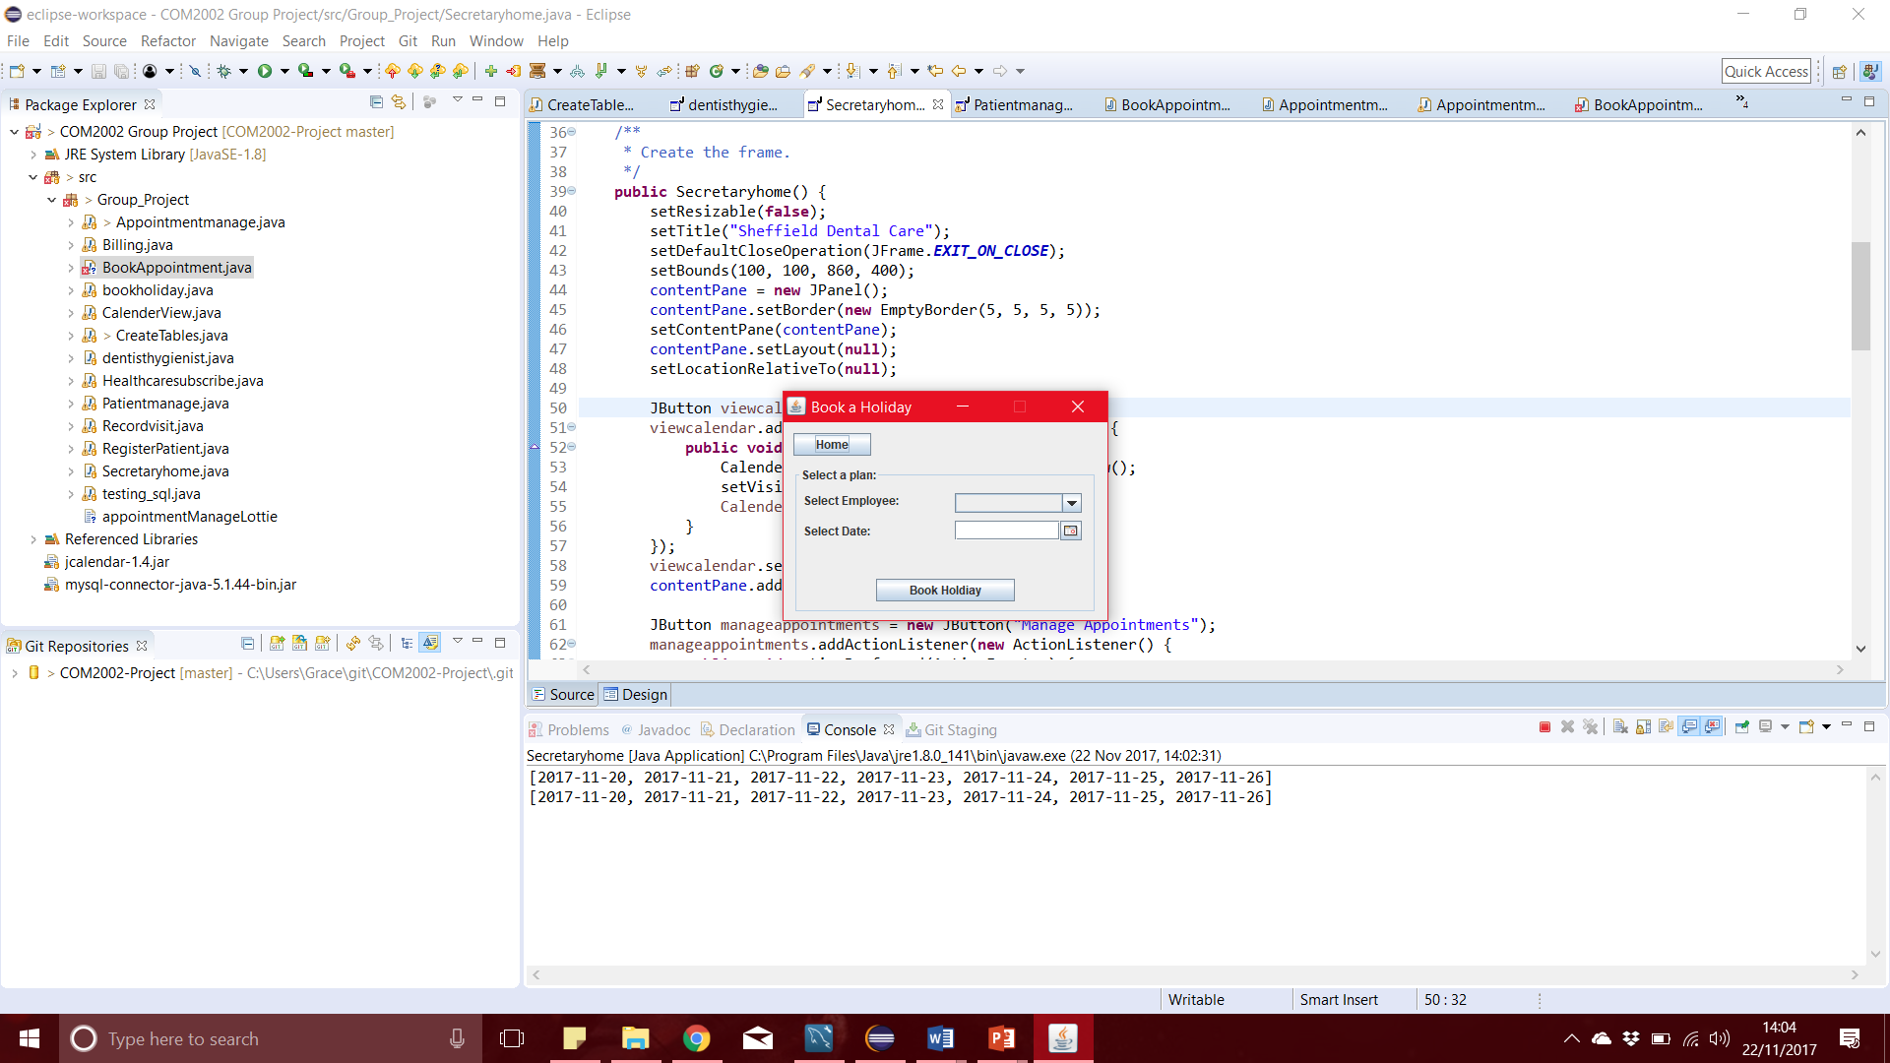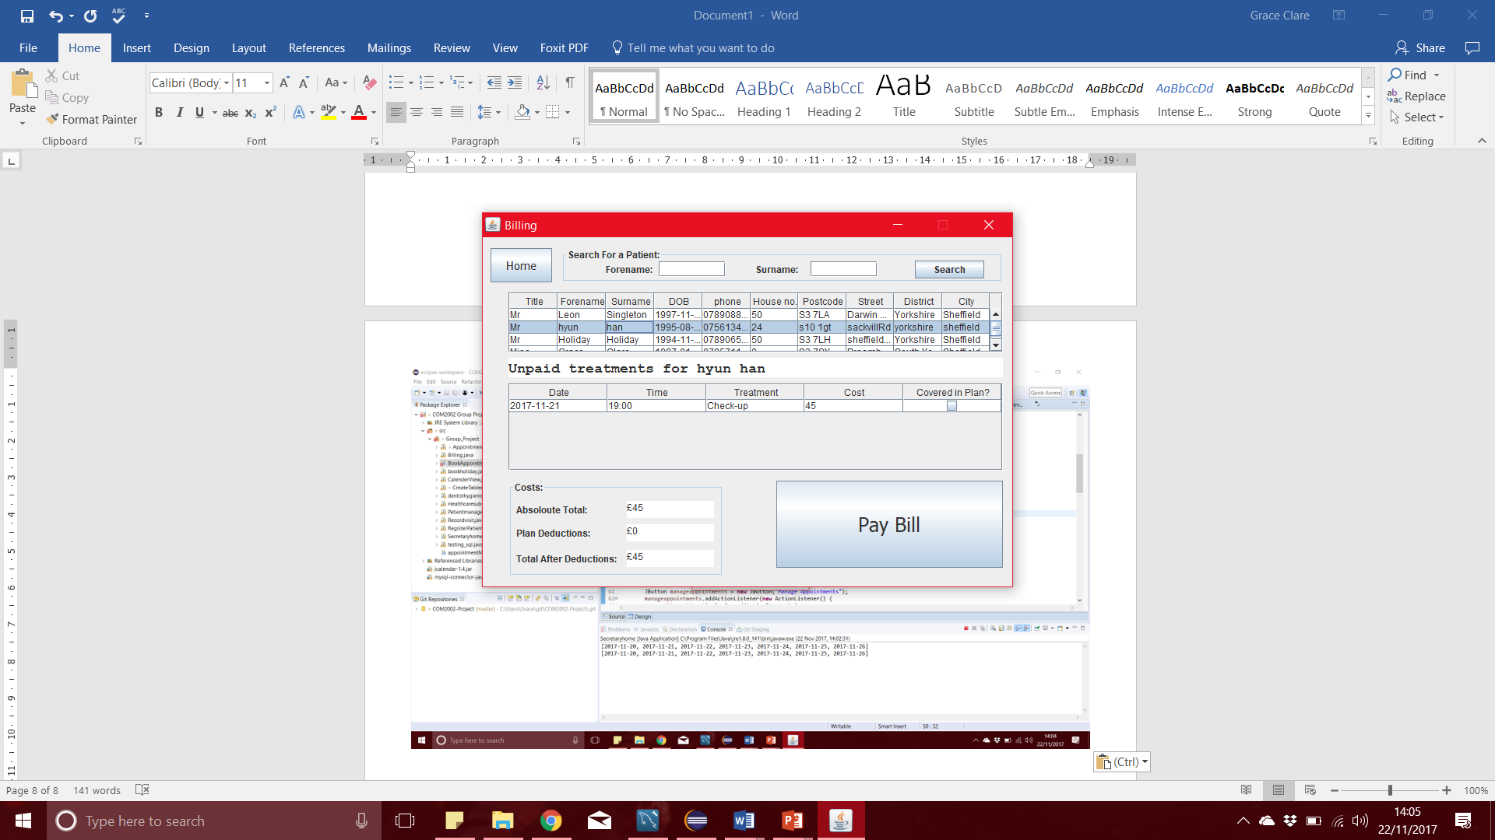To support the secretary’s duties in the system we have designed the UI pages regarding his/her duties with desktop/laptop use in mind. We tried to make the use of the pages intuitive, by keeping buttons that do similar things in the same place, for example the home button is always in the top left corner so that the system can be learnt and used easily

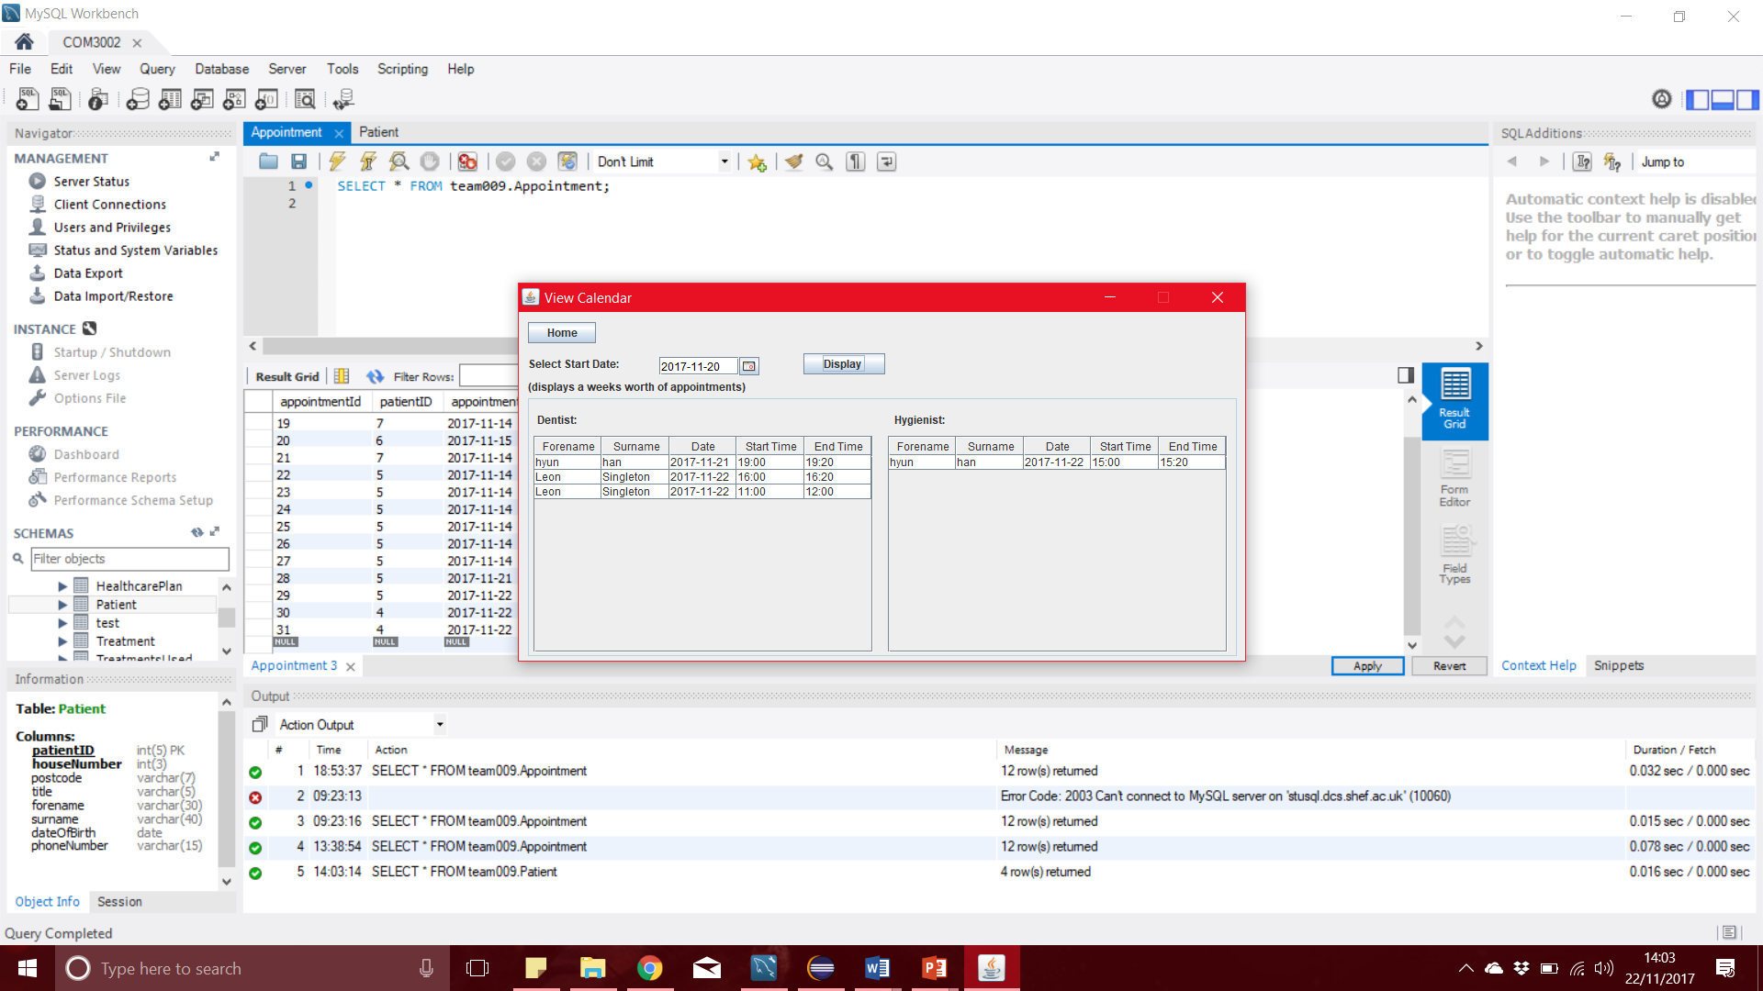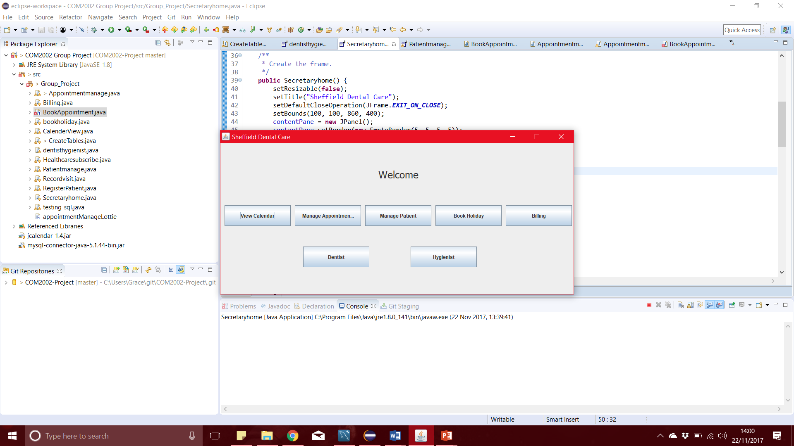

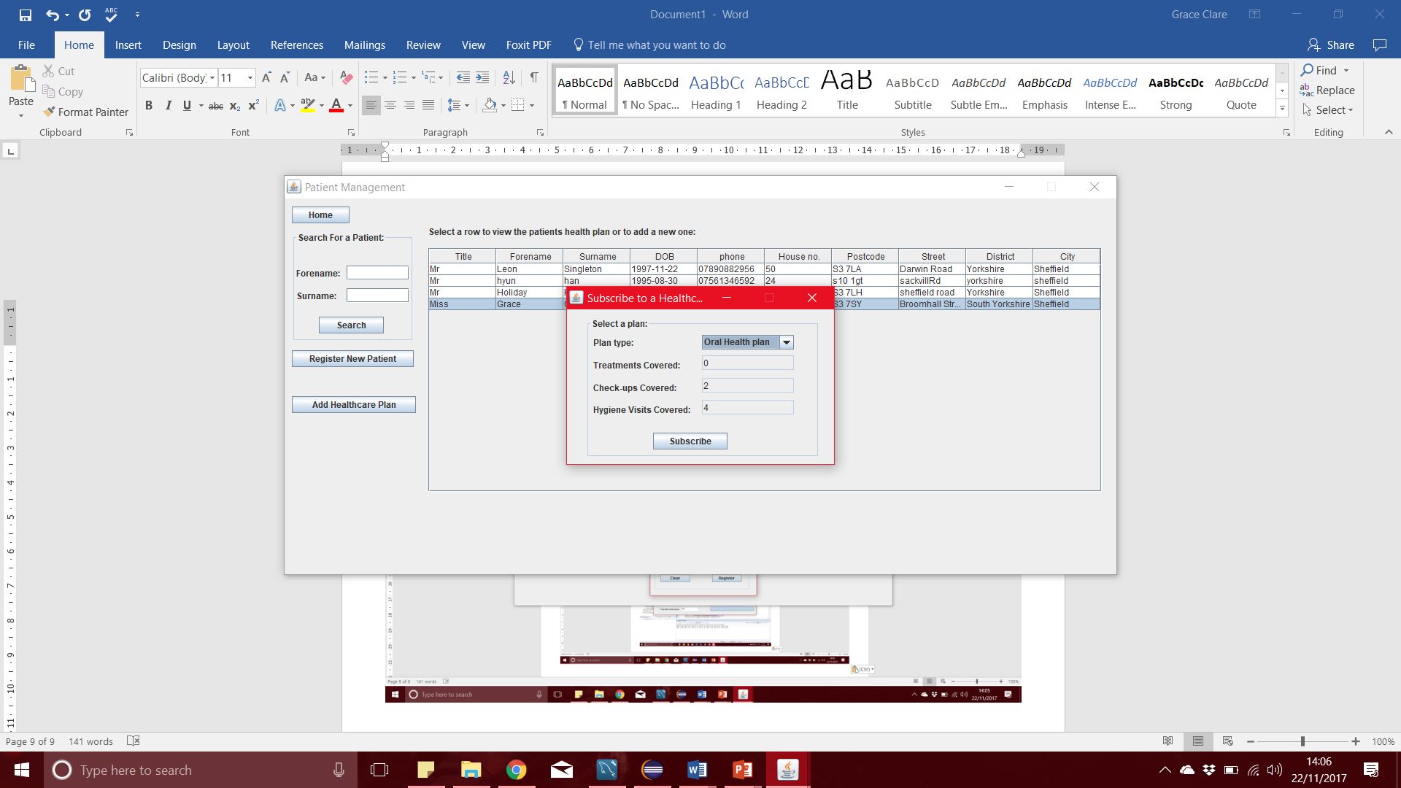

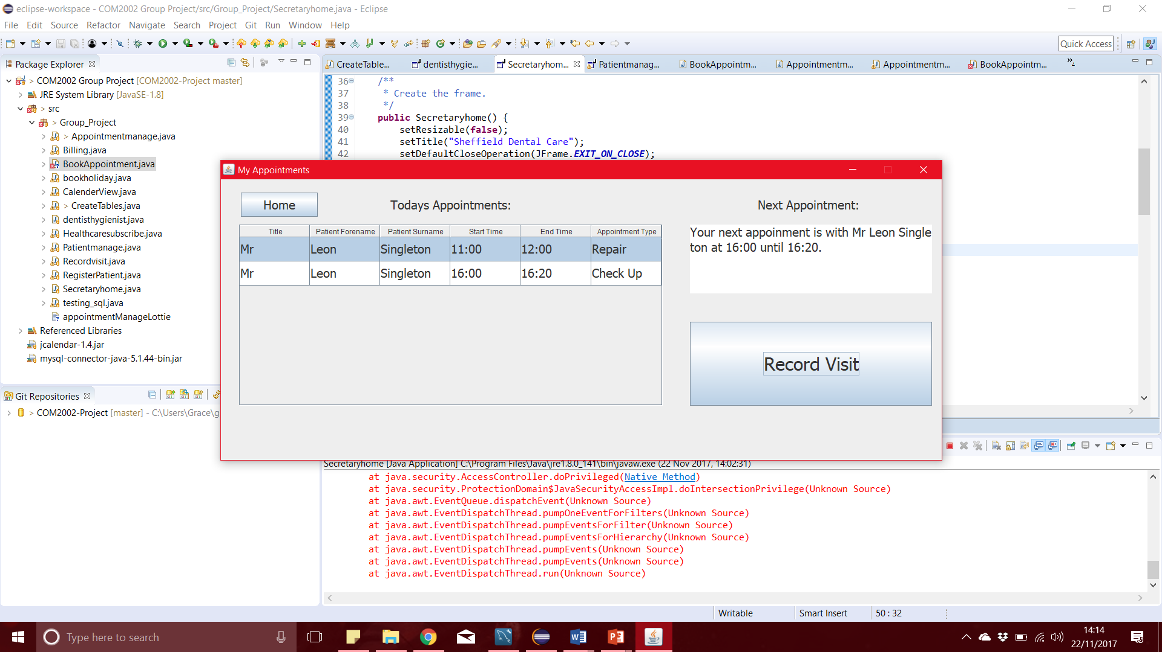

Partner User Interface

To support the fact that the partners use the system on a touch screen device, the interface has been designed so that it has large text and buttons. It also does not require any typing from the user making using it on a smaller device simpler.

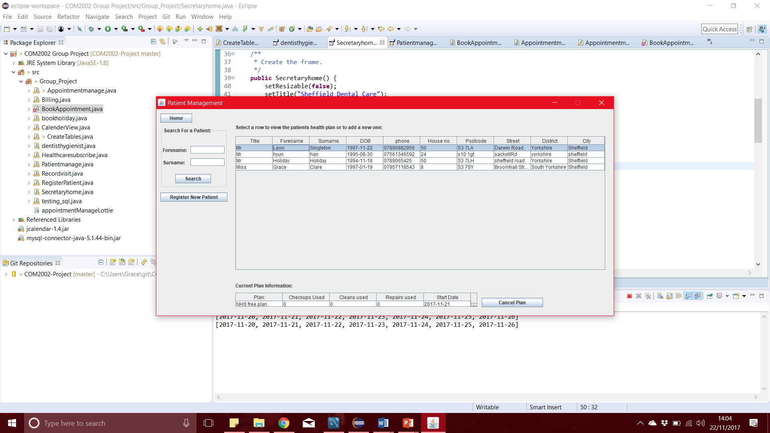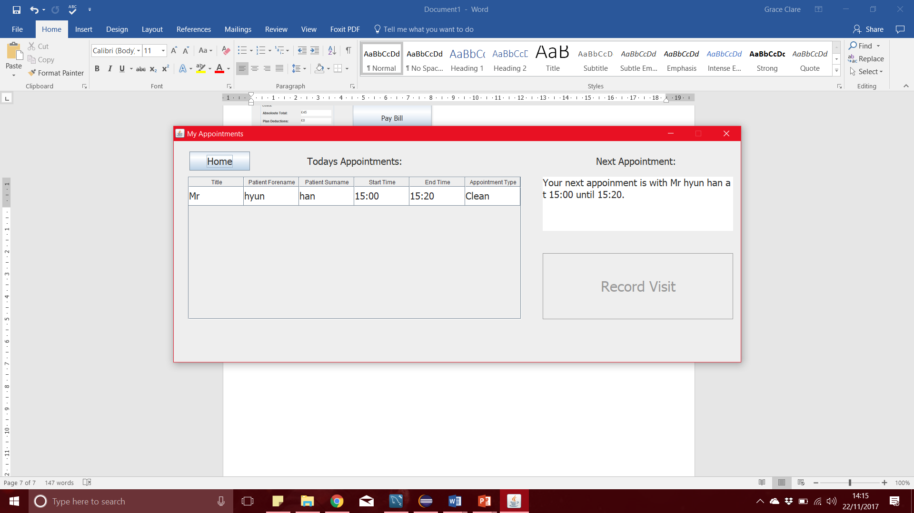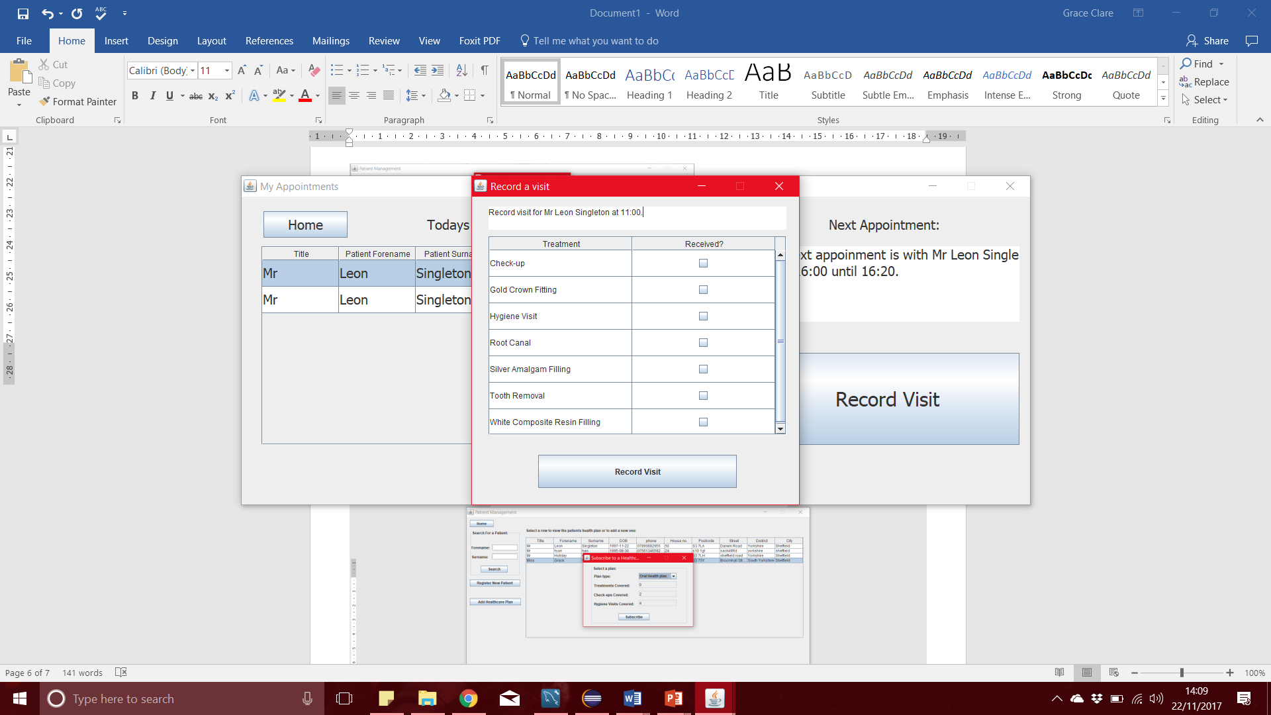We also tried to keep the interface from being too cluttered so that the partner does not accidentaly press the wrong button or get confused. We made sure that the rows in the record visit form are large enough that the partner won’t accidentaly select the wrong treatment.

Evidence of Query Processing:

Registering a new patient and then showing that the new patient exists in the DB:

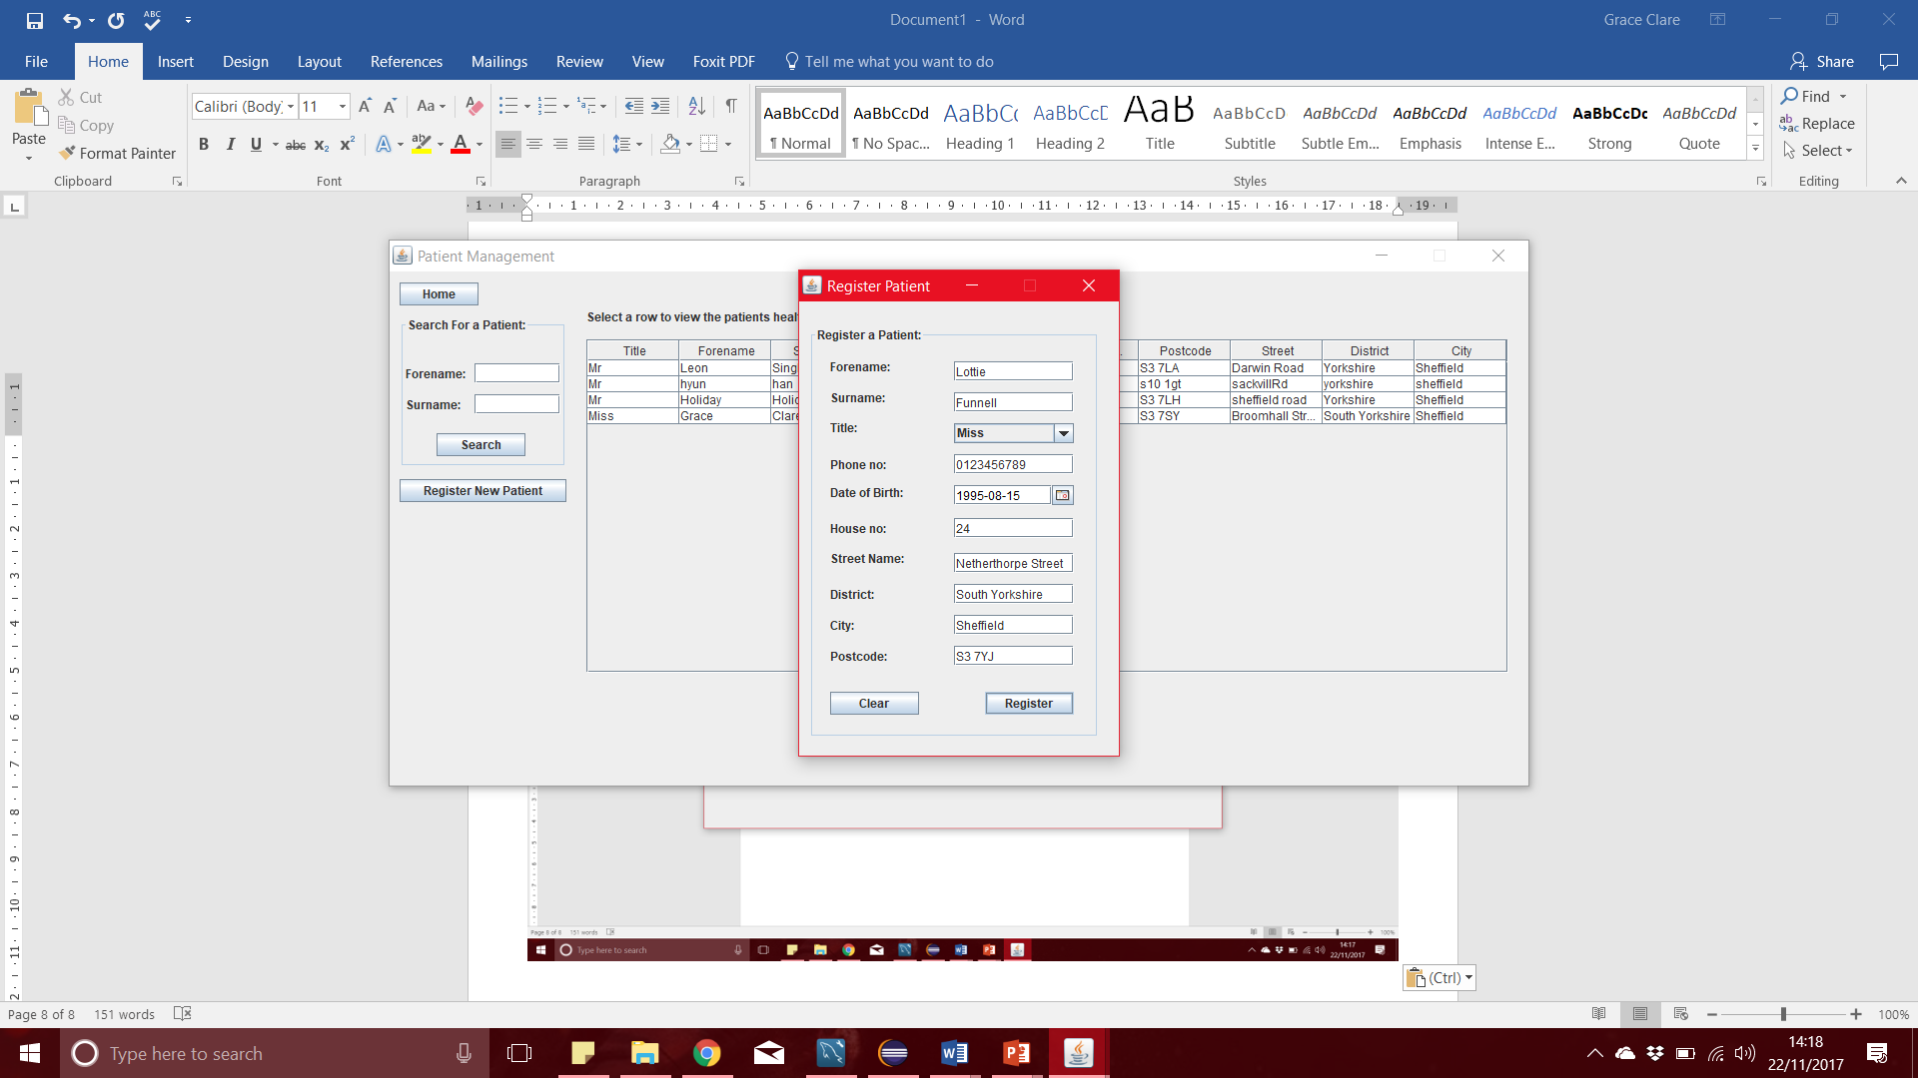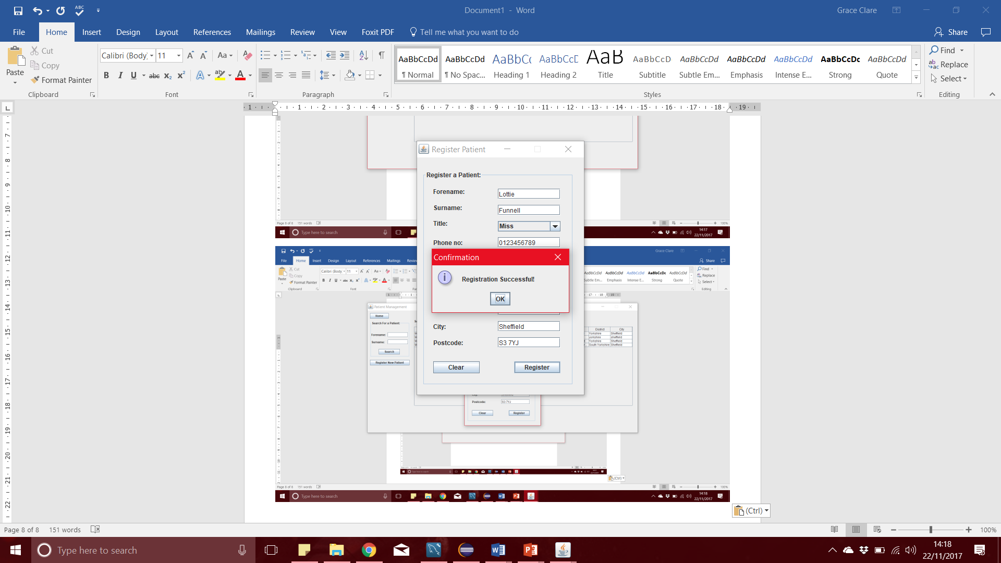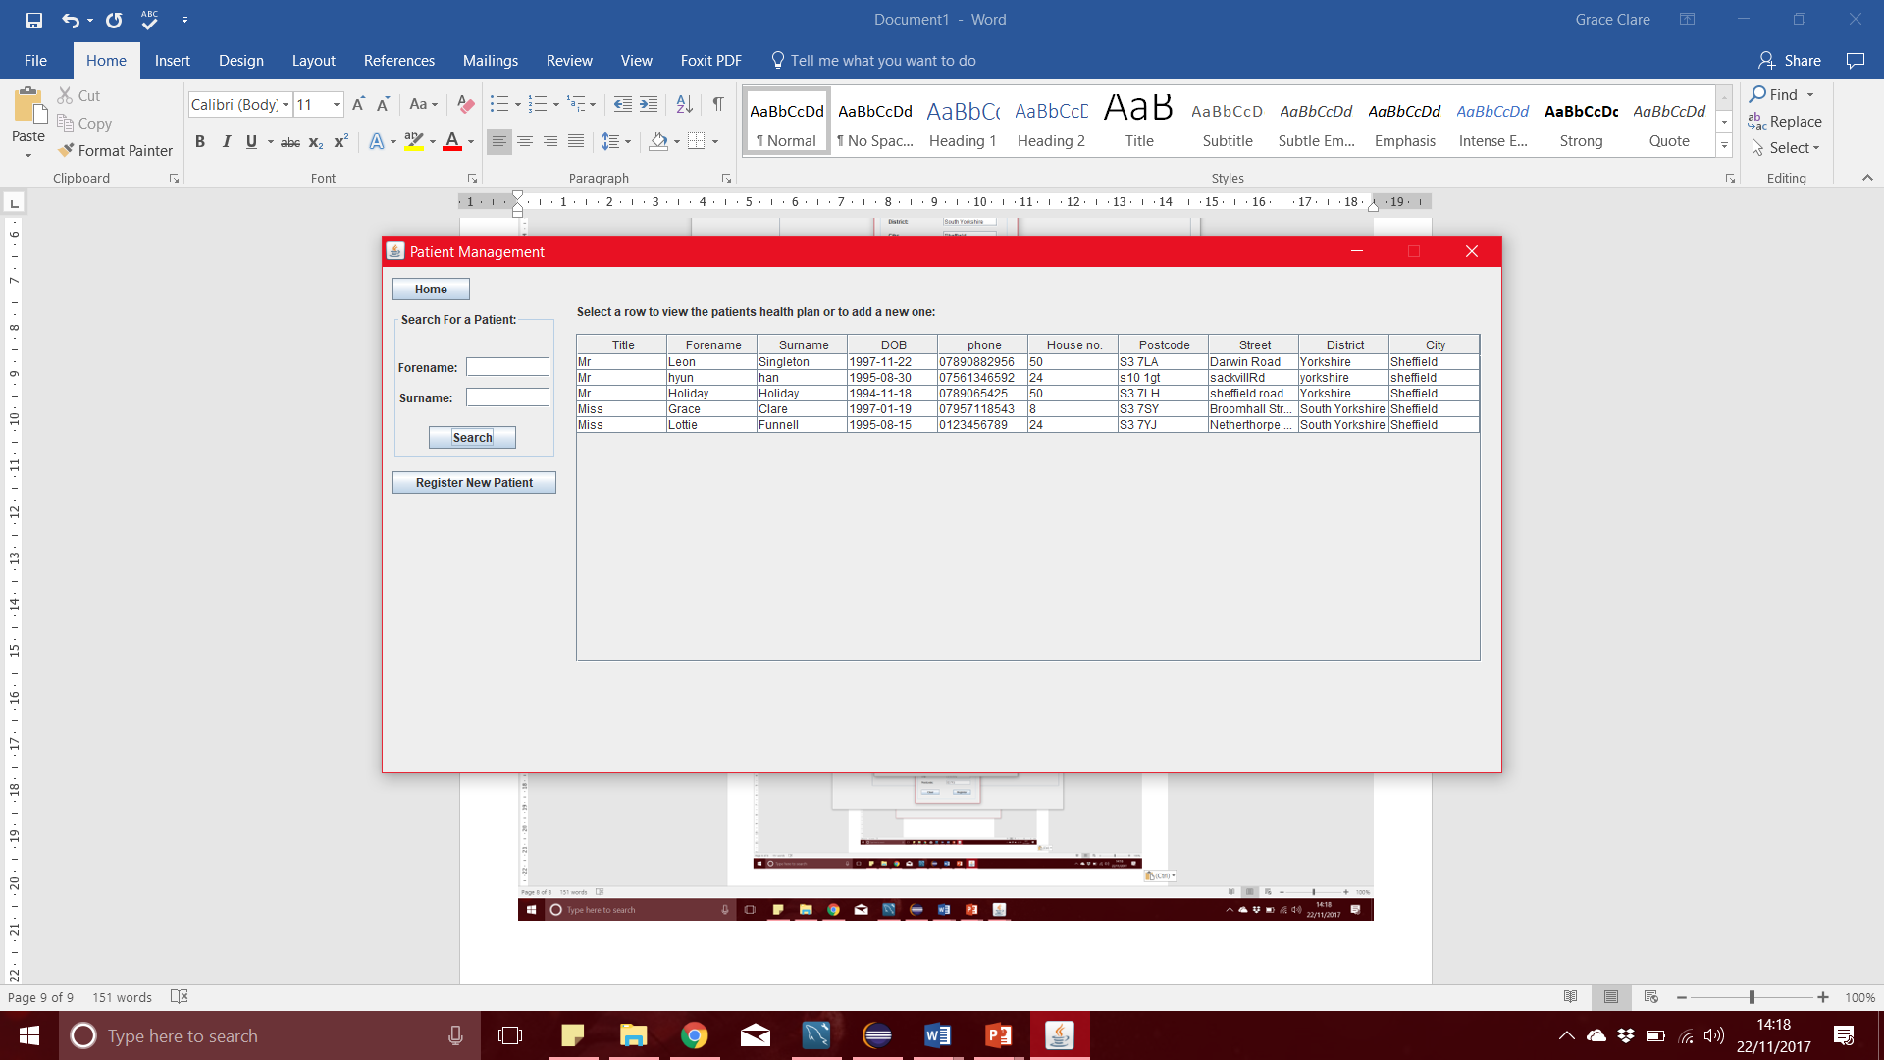

Subscribing a patient to a healthcare plan and then showing that the patient is linked with the relevant plan in the DB, through a new record of relevant treatment-credits for the plan, for the current year :

In our system, the credits are initialisd at 0 and increase with every treatment used by the patient.

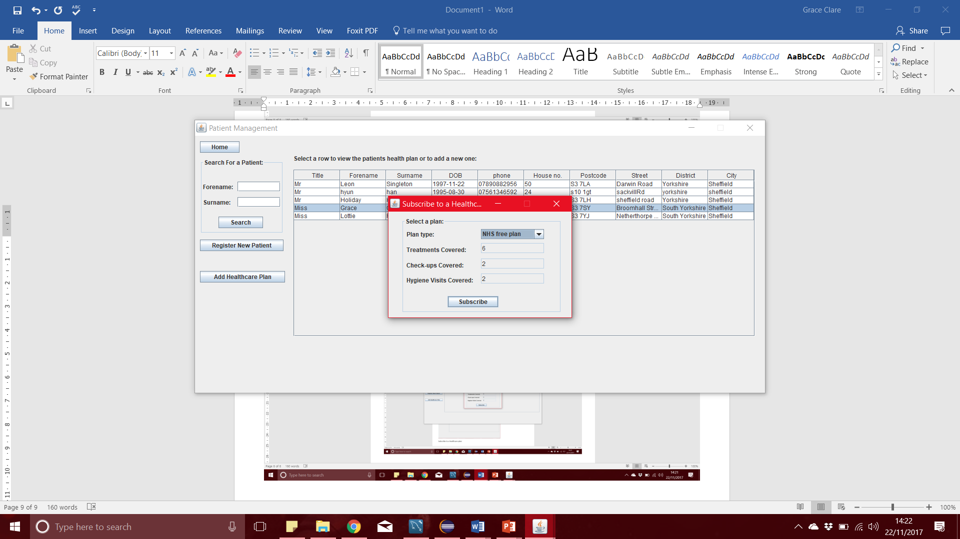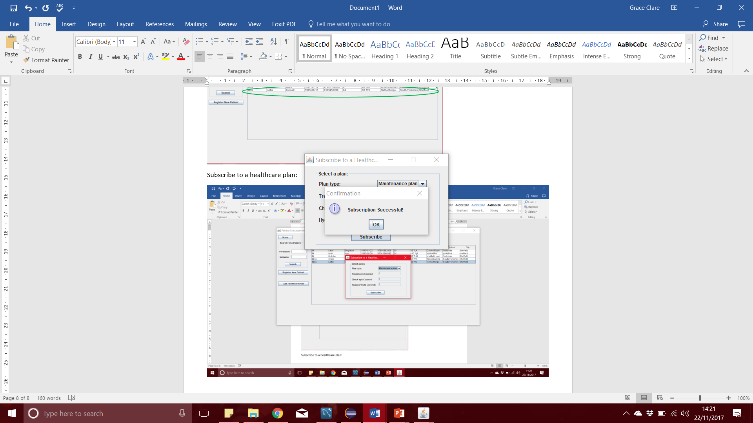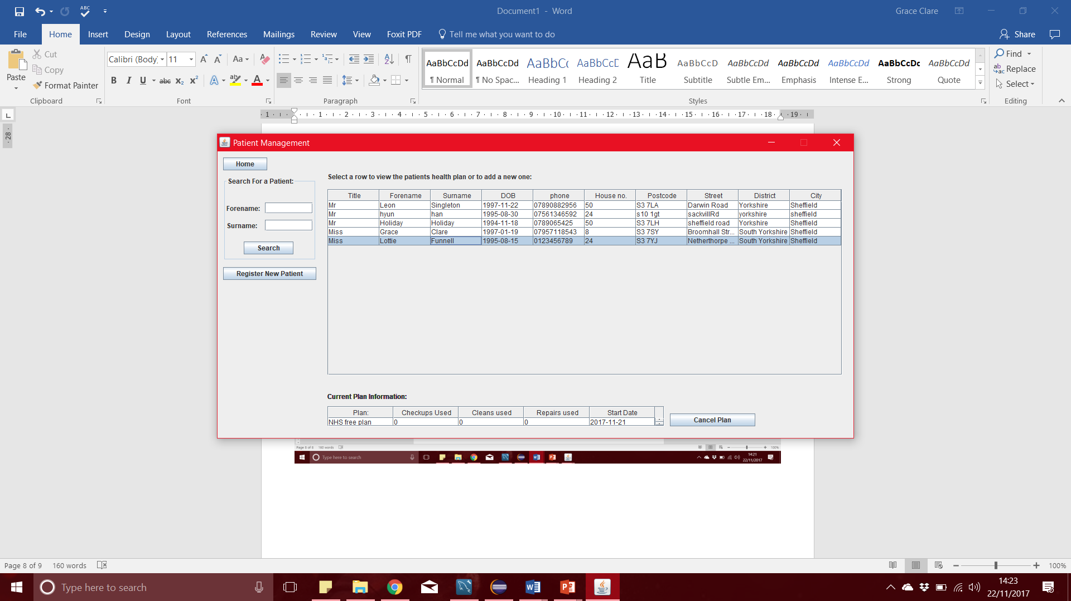

Creating an appointment for a patient to see the dentist and showing that this appointment appears in the receptionist’s week-to-view calendar for the dentist, and also appears in the dentist’s appointments for that day:

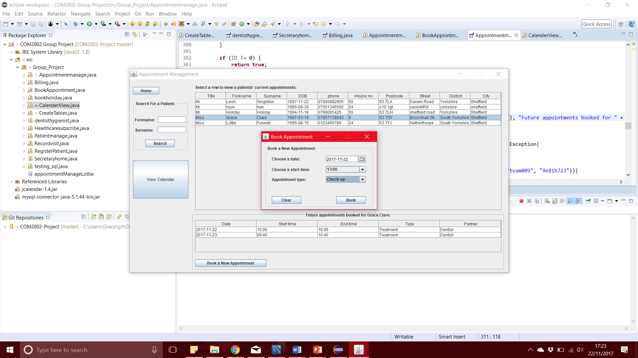

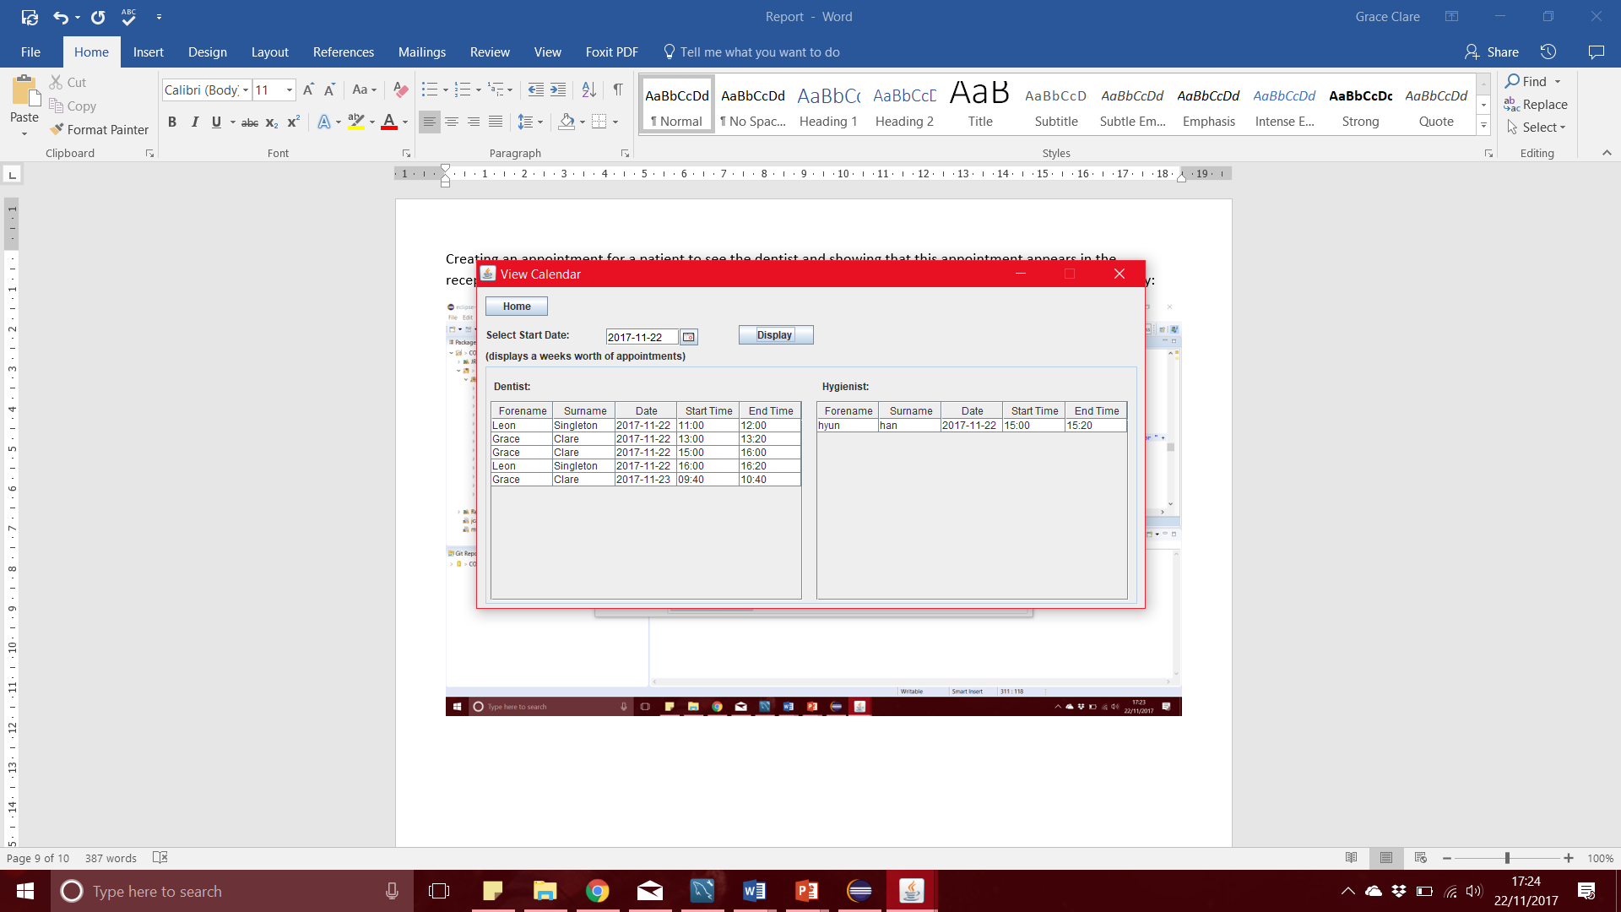 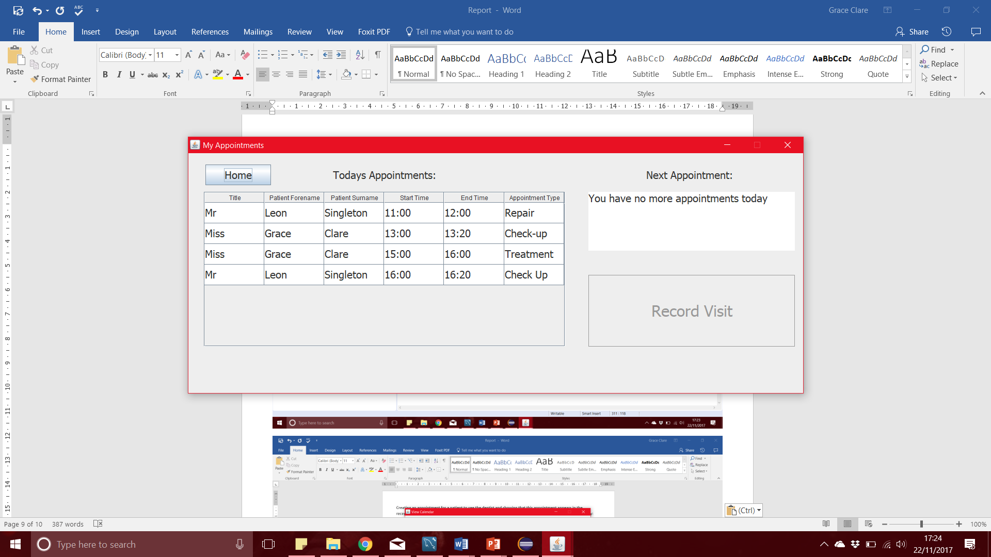

Attempting to create two appointments for a patient that are refused, either because the patient or the partner already have appointments at this time:

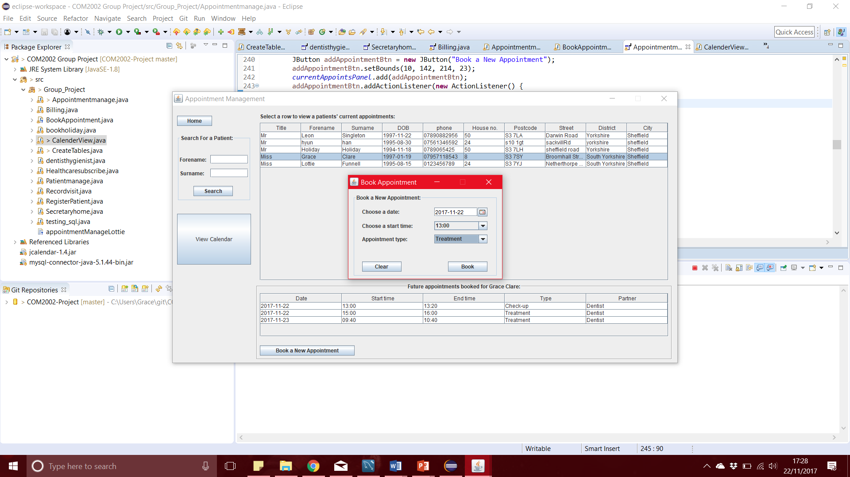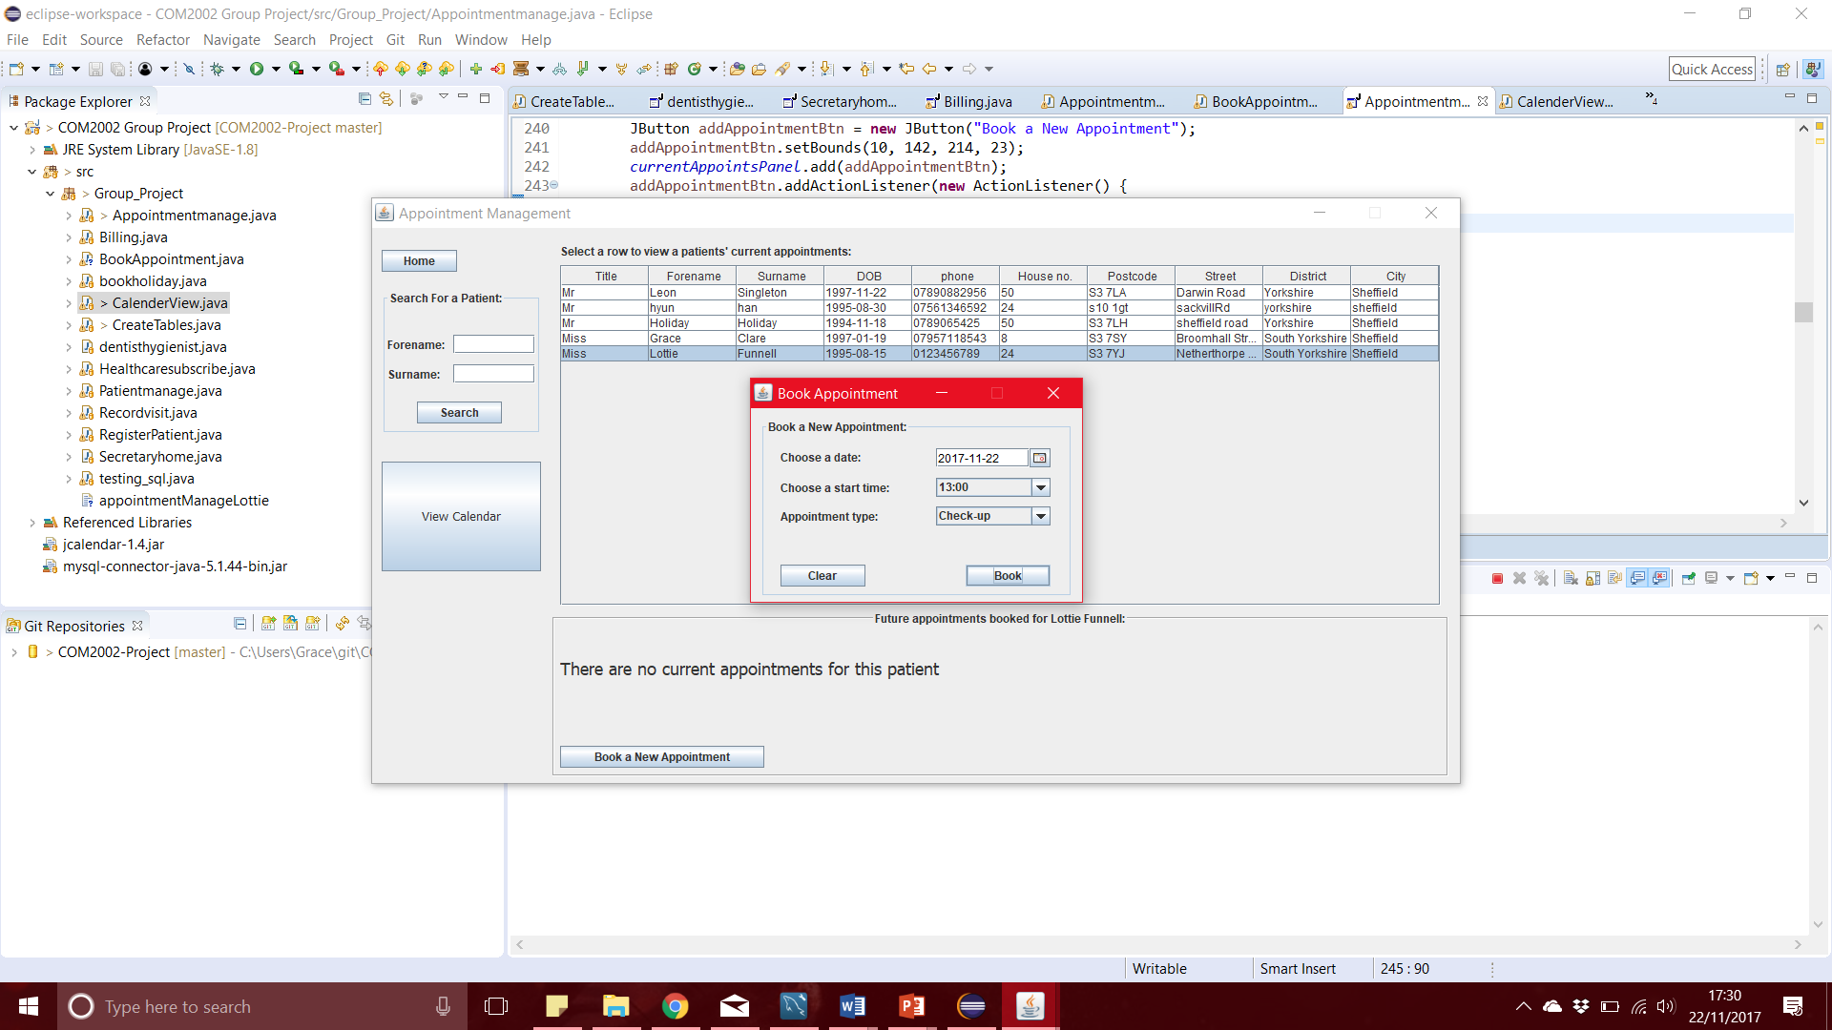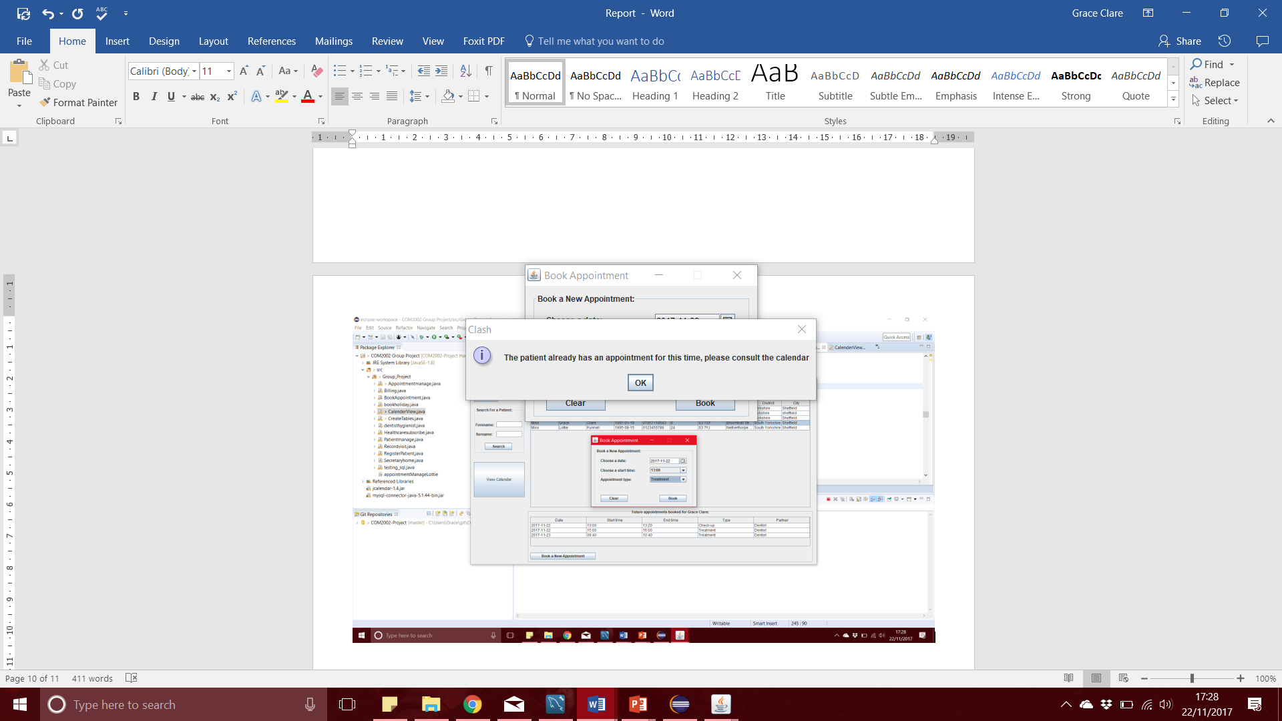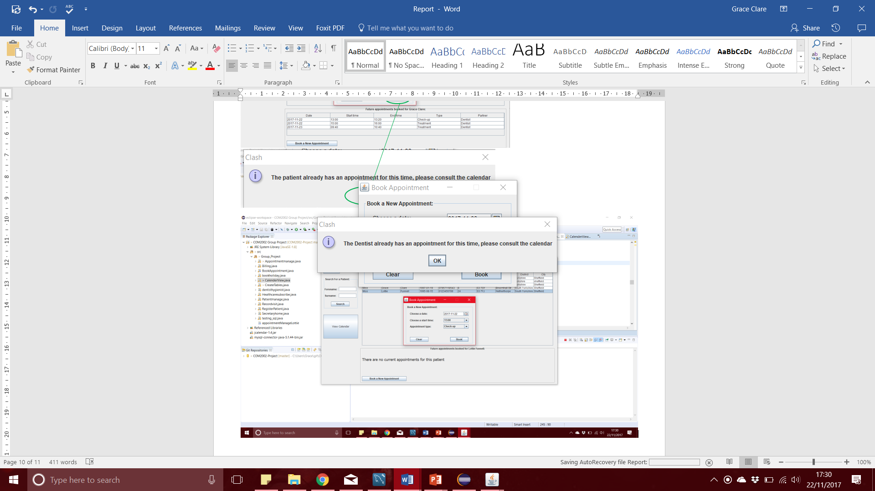

Booking two days holiday for the hygienist and then showing that blank appointments fill the relevant two days on the hygienist’s week-to-view calendar: 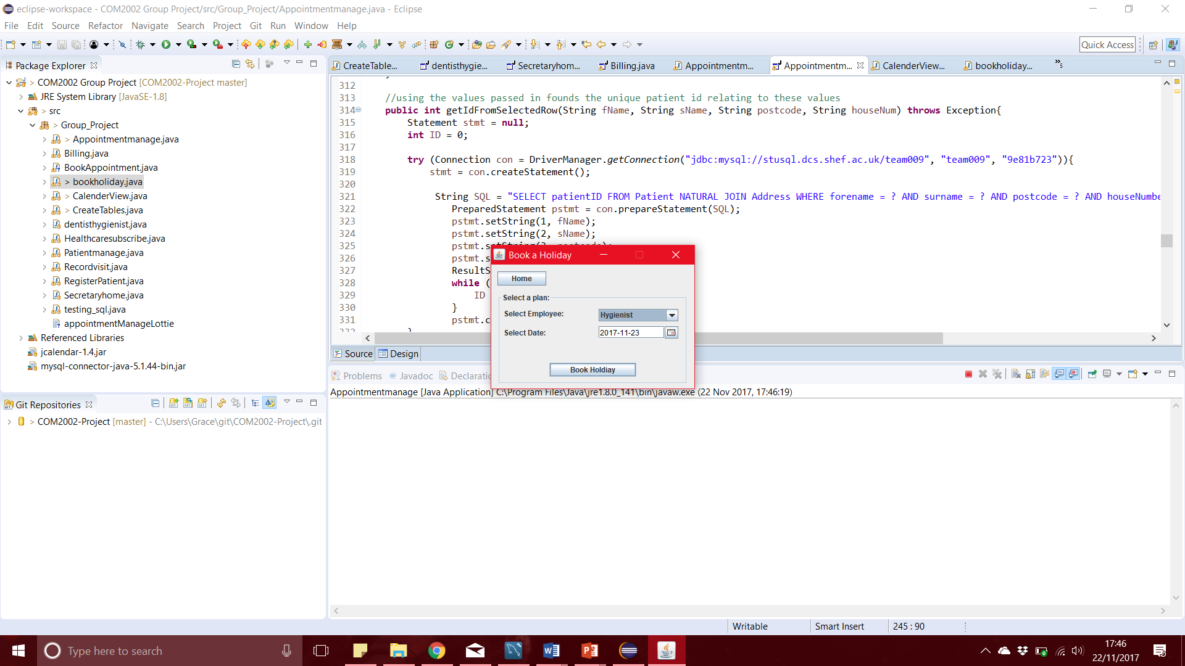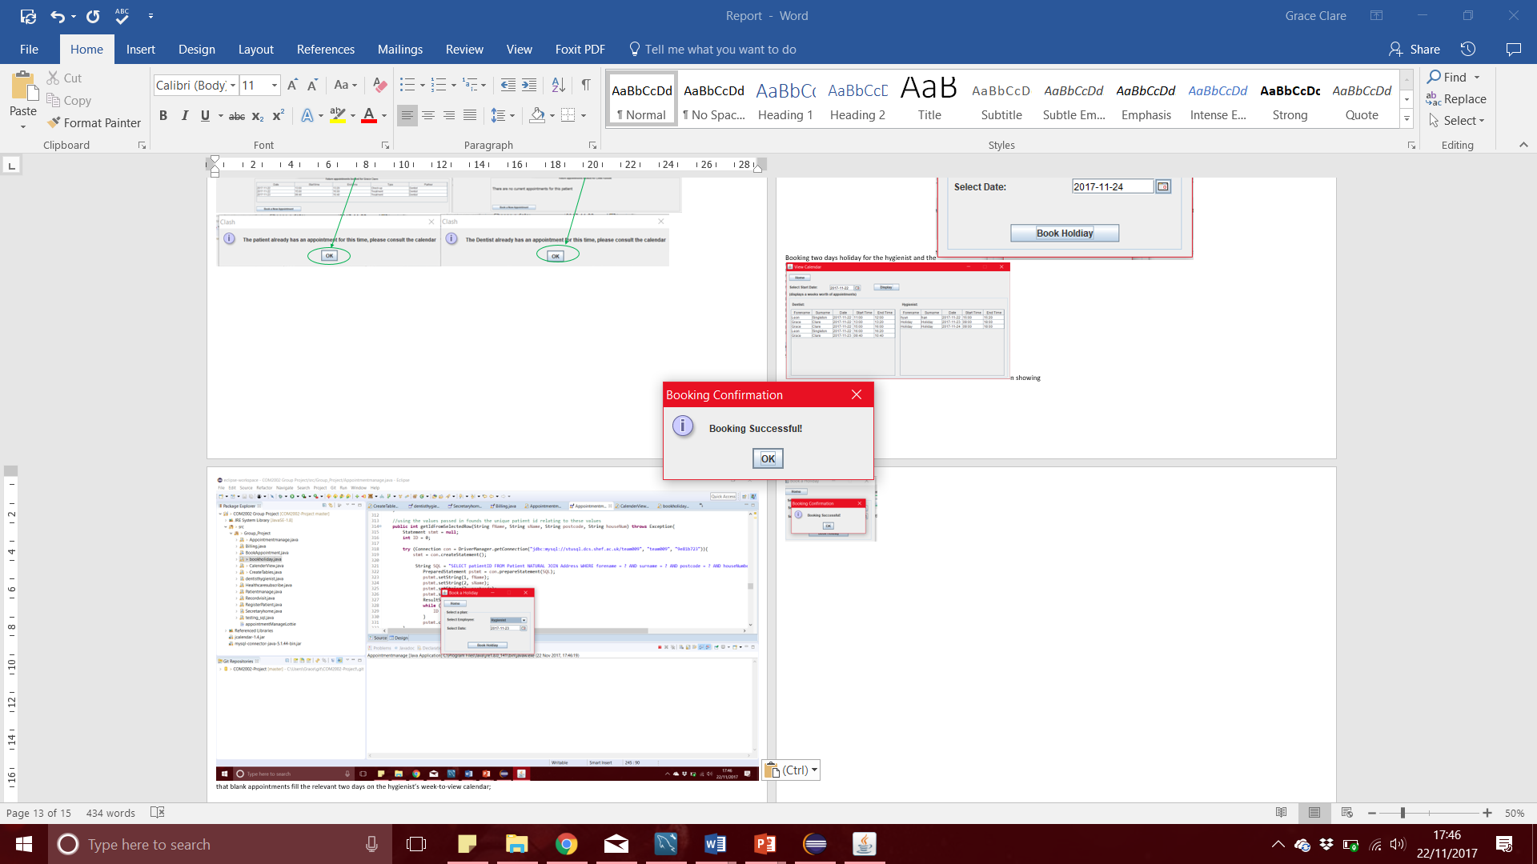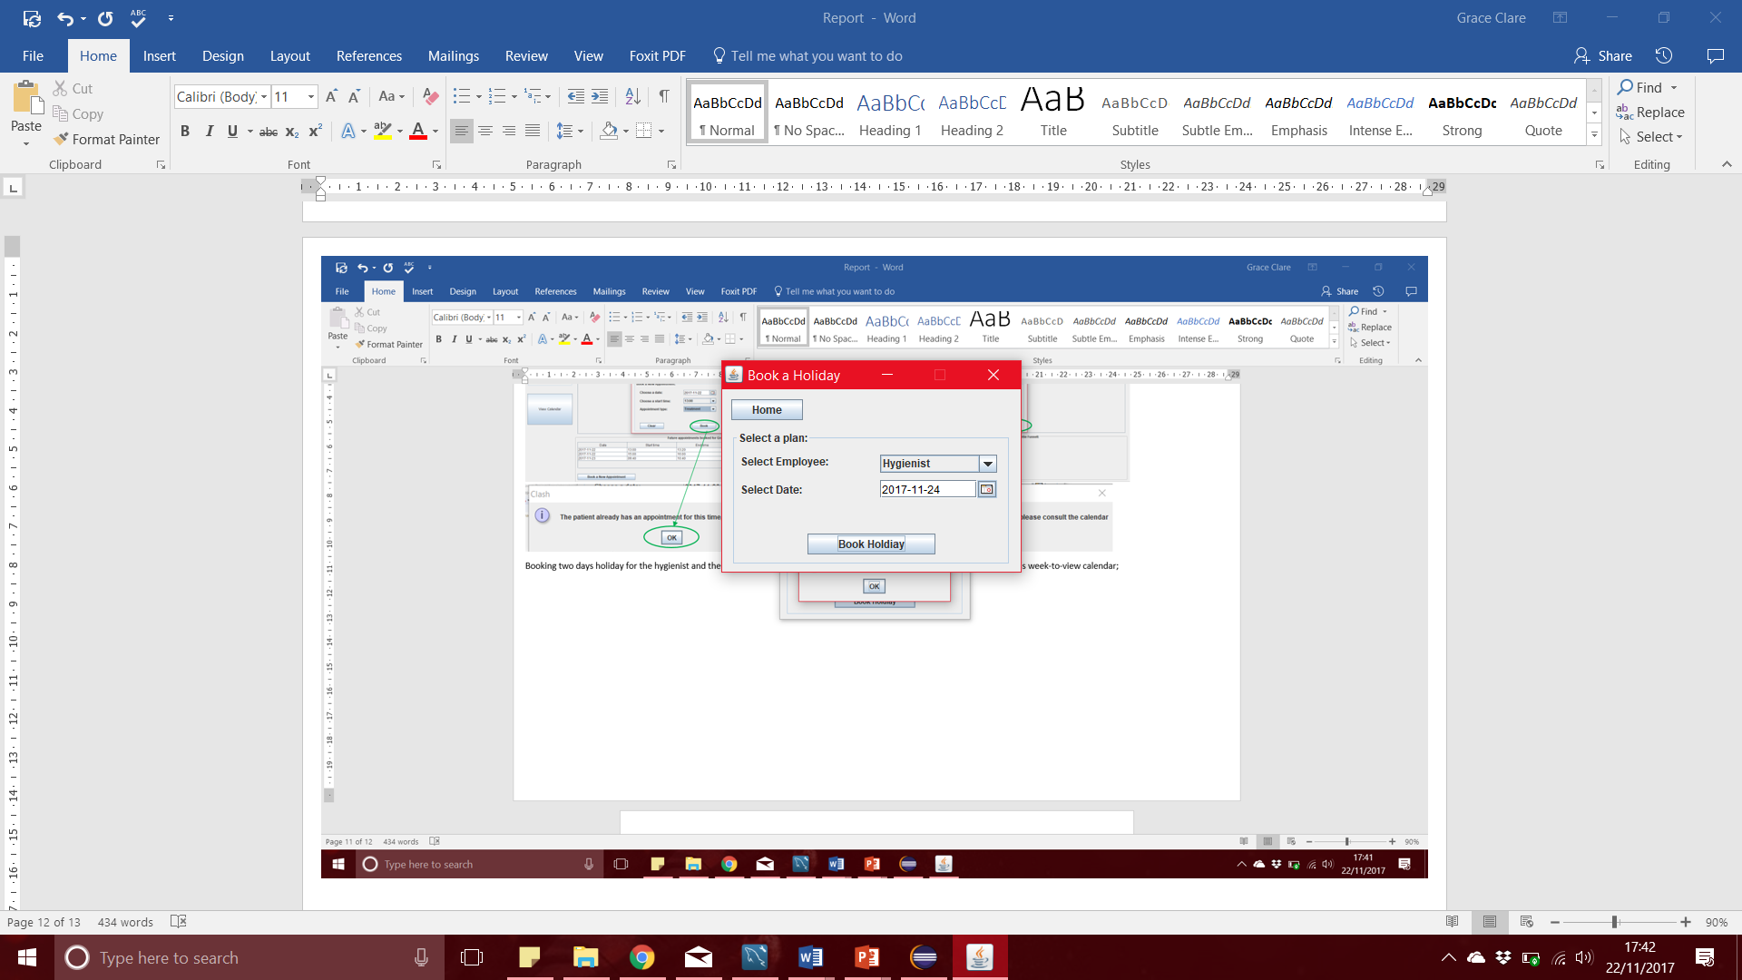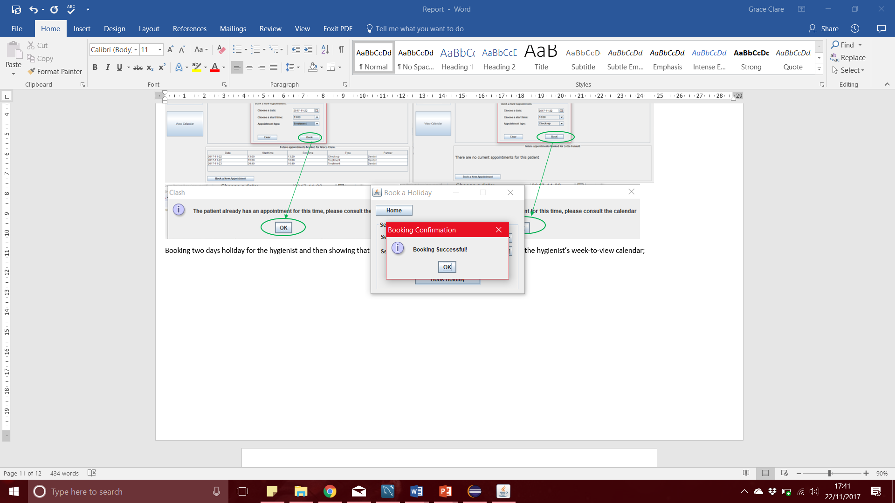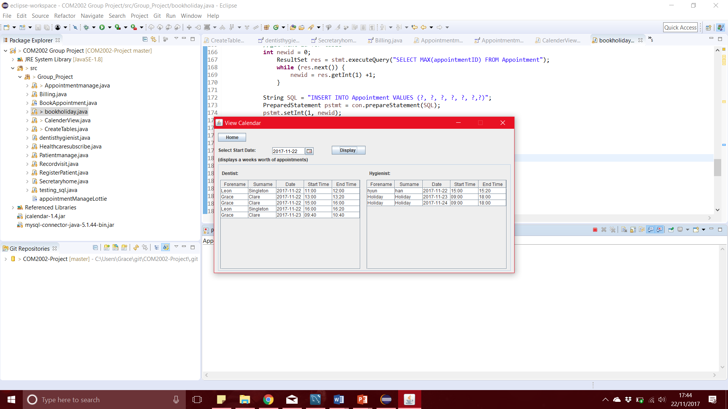

Recording two treatments given by the dentist to a patient and then showing that these have been added to the bill for the appointment;

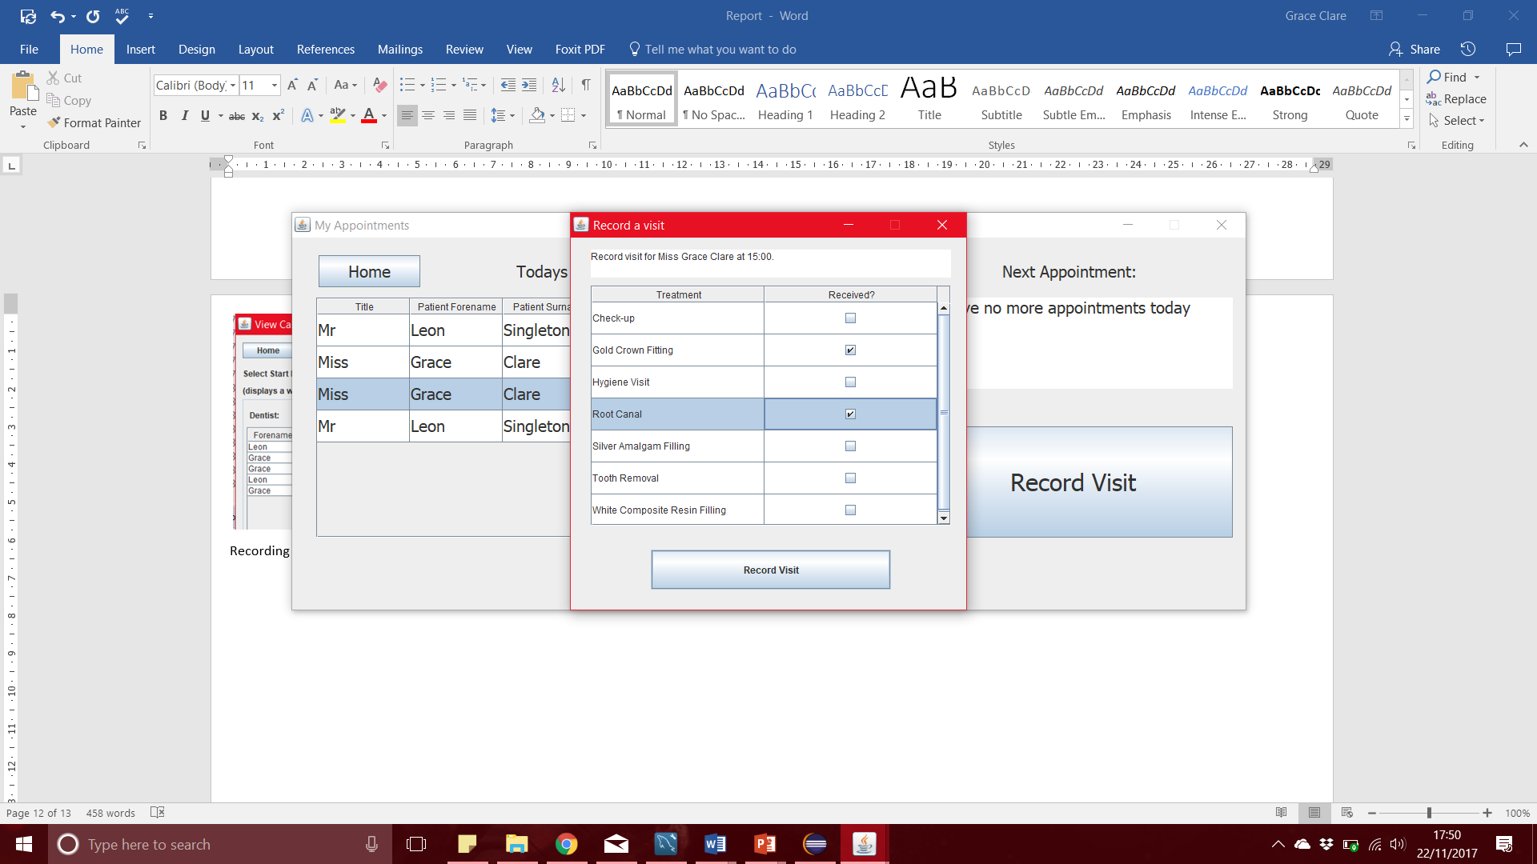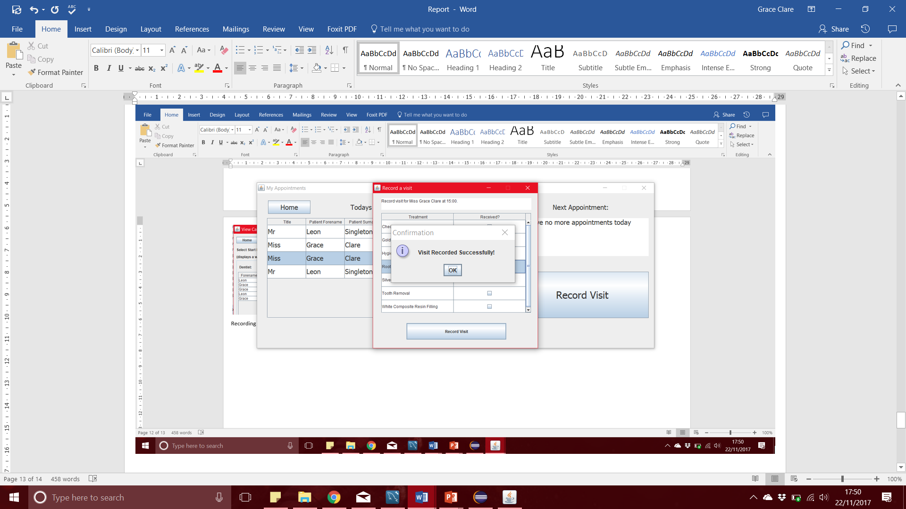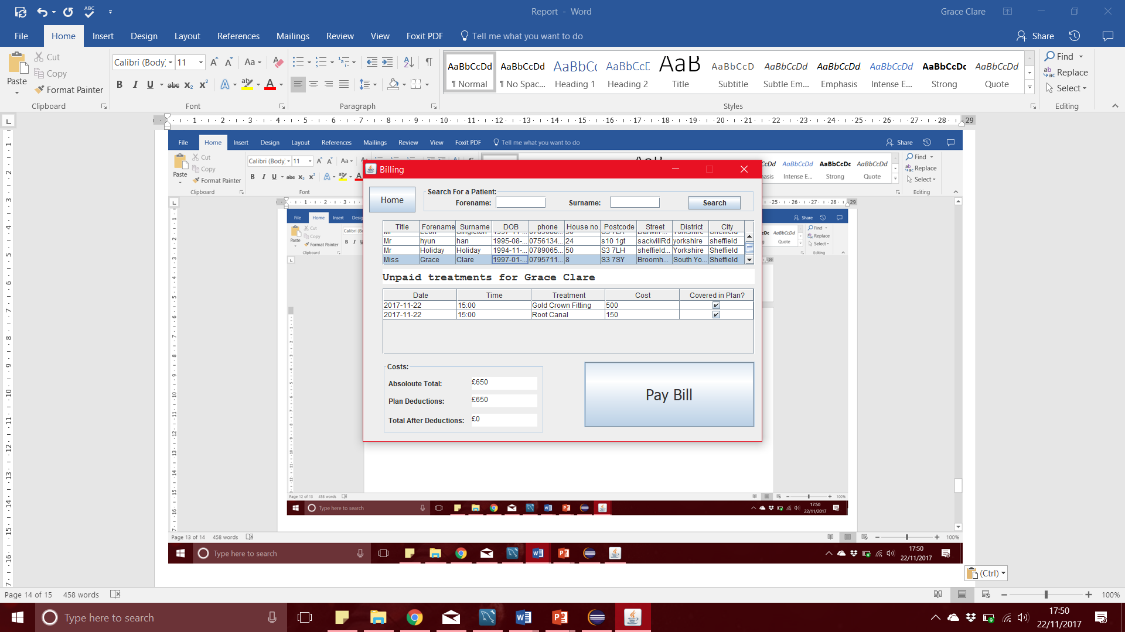

Displaying the total cost of an appointment for a patient who is on a healthcare plan, showing the total cost of treatments and the amount owed by the patient; 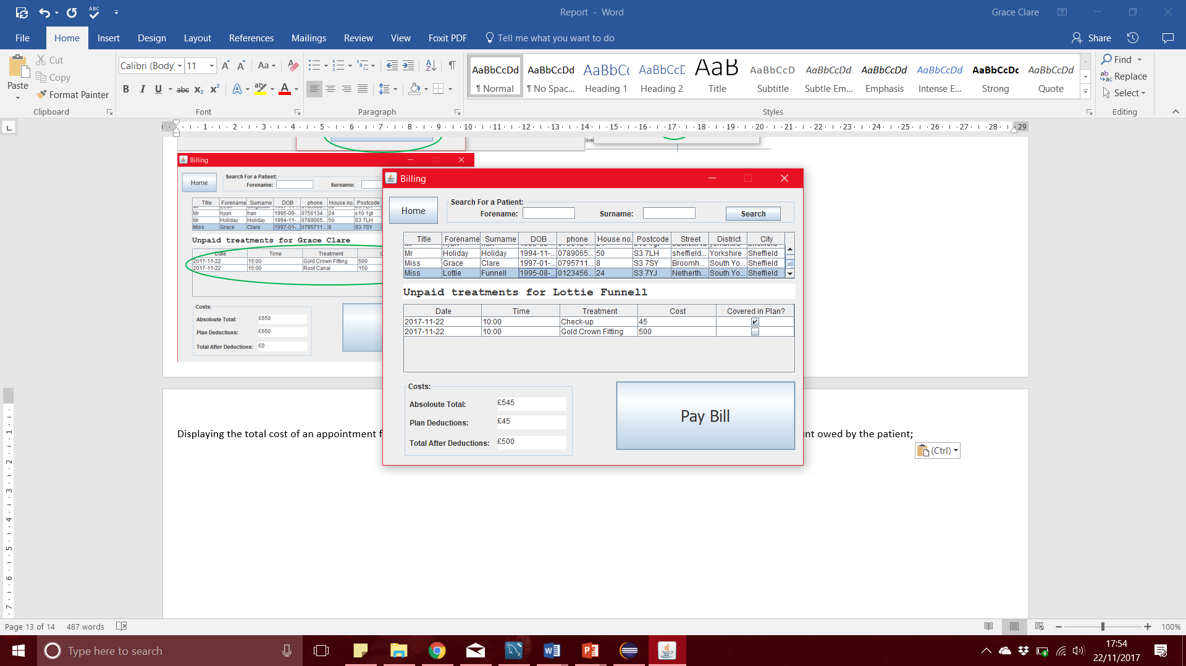

Processing a payment by a patient who is on a healthcare plan, showing how their treatment-credits for that year are adjusted, and that they now owe nothing:

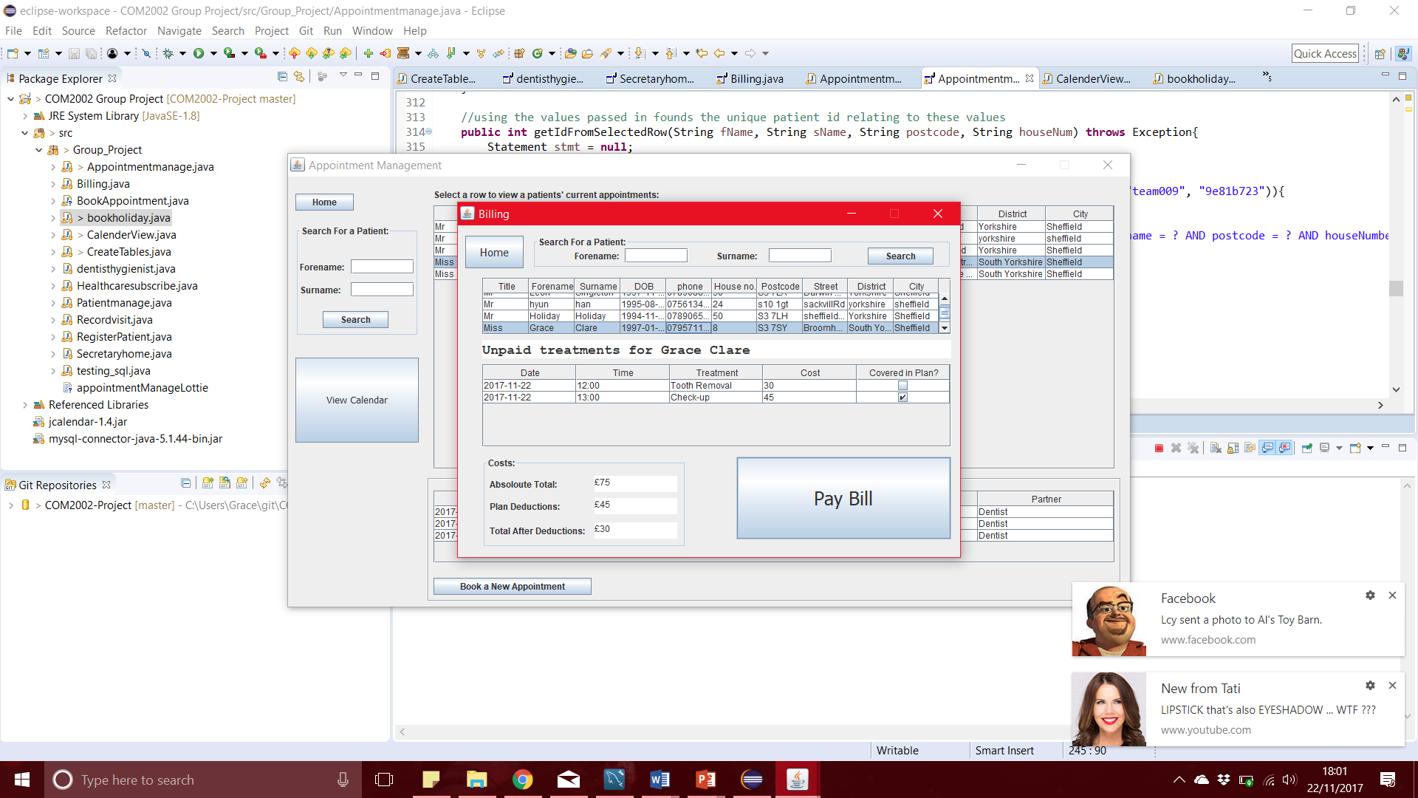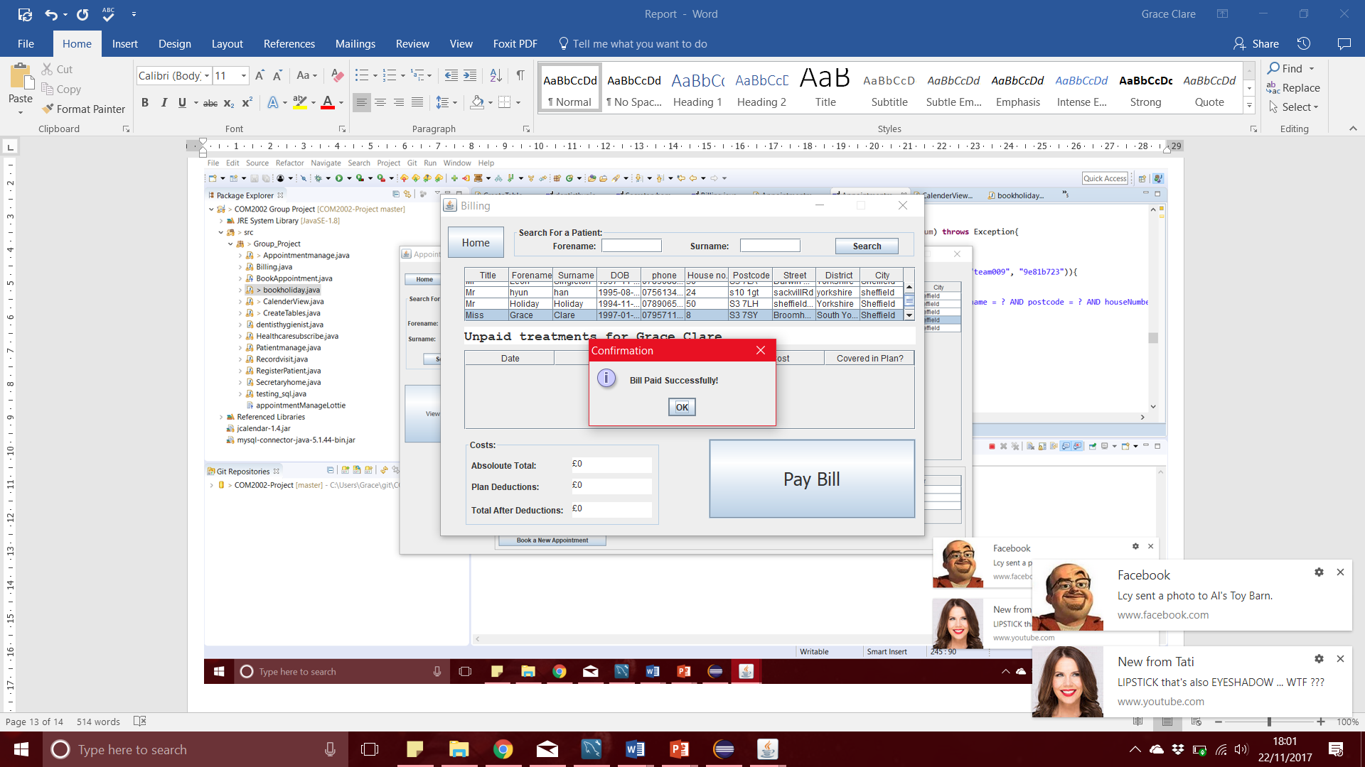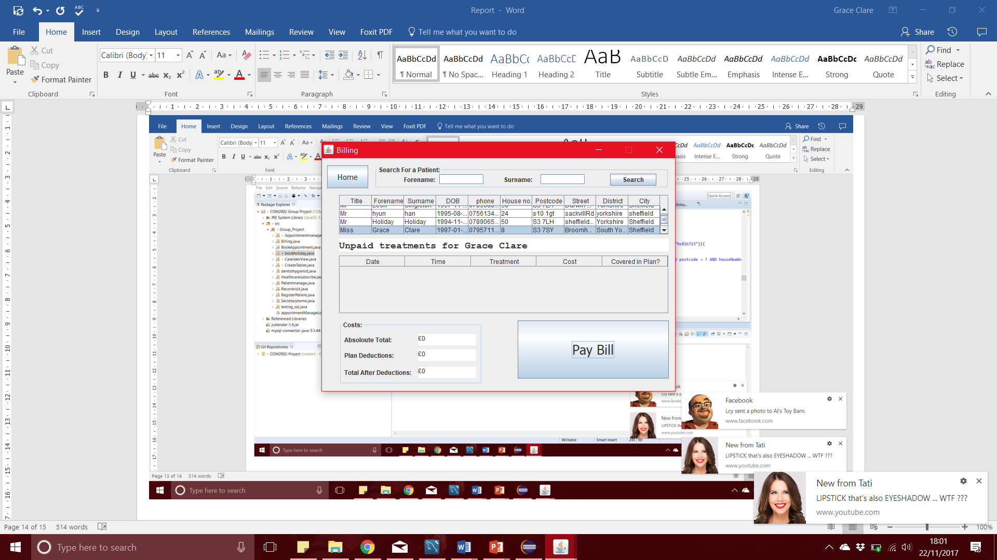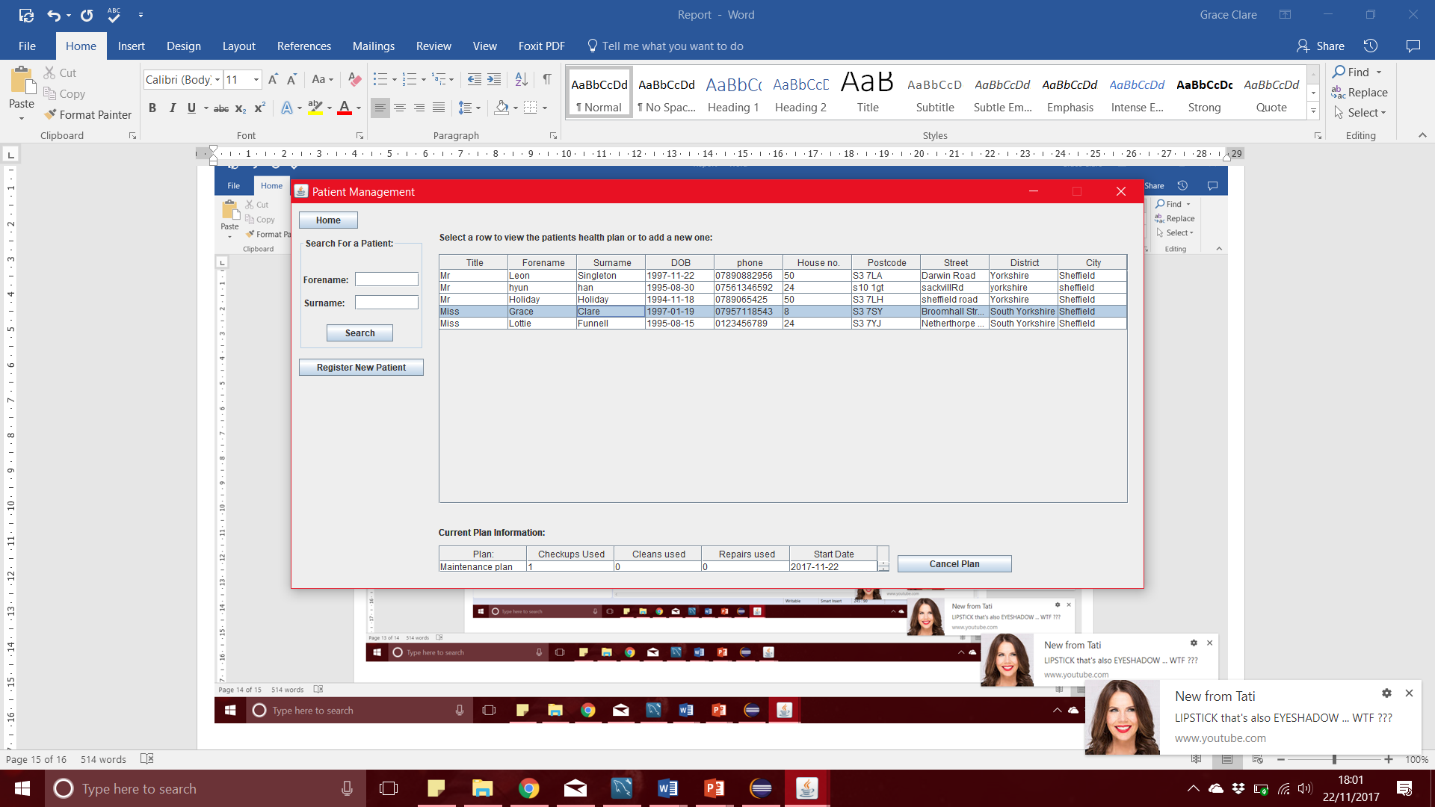

Effort Declaration:

The diagrams were split evenly between the group, and we all worked equally producing these with no issue. The user interface was split between everyone evenly but due to some errors other members of the group assisted with the view calendar and manage appointments pages. Overall, we worked effectively as a team and produced the required content in a timely manner.

|  |  |
| --- | --- |
| Hyun Han | * Use Case Model * Normalised Data Model * Book Holiday Form * View Calendar |
| Leon Singleton | * Use Case Model * Normalised Data Model * UI Mock Ups * Manage Patient page (manage healthcare plans, register patients) * View Calendar |
| Grace Clare | * Information Model * Normalised Data Model * Created Database * Partner user interface * Billing Page * Manage Appointments Page |
| Lottie Funnell | * Information Model * Normalised Data Model * Manage Appointments Page |

|  |  |
| --- | --- |
| Hyun Han | 100 |
| Leon Singleton | 110 |
| Grace Clare | 120 |
| Lottie Funnell | 70 |

All members of the group agree with this declaration:

Grace Clare Leon Singleton Hyun Han Lottie Funnell